CREATING & MANAGING PROJECTS/SURVEYS IN THE BDRS

Notes

## This Document

This document attempts to be many things

* a self learning guide,
* piecemeal support for training course notes which reach into it for bits relevant to the audience, and
* a reference manual.

Currently it is structured as verbose training notes. The material could be reorganised into a more conventional manual form but the intent and requirement here is to lead new administration users through the material in a serial, layered fashion allowing them to “grow into” the functionality and complexity in small steps.

While the result is a bit of a mixed bag we know that it contains most of the things you will need to know and the content will be maintained and updated on line so it can develop as the BDRS matures and evolve into a better tool with your considered feedback.

## Introduction

The BDRS is primarily about field data capture and providing useful supporting capabilities to targeted users within a contained scope or context – for example a region, a specific species or taxonomic group, a particular area or activities of interest – for example water quality, weeding, tree planting, and so on.

This document is about how to create & manage BDRS projects or surveys.

The “vanilla” menu options and administration pages call them projects but, because the BDRS has so far been mainly used for surveys of species, they are often called surveys in themed BDRS web sites.

We use the term interchangeably in documentation and discussion. Naming of the surveys and theming allow you to call them what you think will best address your users’ experience and requirements

## Survey Options

Surveys come in all different kinds from the simplest, most basic ‘Darwin Core’ type to complex flora and fauna plot surveys, collection and sampling methods and field expeditions.

This document shows how the BDRS can be used for a variety of survey types, starting with creating a Basic Survey and then revisiting it to explore configuration and other options, showing the various survey types and adding layers of enhancements.

Increasing survey capability, including desirable presentation and usability enhancements, inevitably comes with increased complexity for administrators in setting up surveys.

We will do it gradually in the following material.

**Table of Contents**

This Document 1

Introduction 1

Survey Options 1

CREATING & MANAGING SURVEYS 6

Survey Management Access Rights 6

1. CREATING A BASIC SURVEY USING DEFAULT OPTIONS 6

Survey Form – Form Builder 10

Survey Form – Preview 12

Survey Form – Locations 13

Survey Form – Access Control 13

Survey Form – Final Workflow Step: Publishing 14

2. SIMPLE ENHANCEMENTS & EXTENSIONS TO THE DEFAULT SURVEY 15

Simple Field Types 15

Horizontal Rule 16

HTML – On Screen Help 17

User View - simple field based enhancements to a Basic Survey 21

Field Types Reference 22

3. EXPLORING SURVEY CONFIGURATION OPTIONS 24

1. OPTIONS: FORM TYPE 24

2. OPTION: DEFAULT RECORD VISIBILITY 30

3. OPTIONS: TAXONOMY 32

4. OPTION: FIELDS – THE SCOPE ATTRIBUTE 34

5. OPTION: LOCATIONS 40

6. OPTION: ACCESS CONTROL 48

4. DEVELOPING MORE COMPLEX SURVEYS 50

1. Non-Taxonomic Surveys 50

Creating a Non-Taxonomic Survey 50

2. Census Methods 51

Creating a Census Method 51

Adding Census Methods to Surveys 54

2. RECORDS MODERATION – THE DETAILS 58

The Survey Form: Create & Edited 58

The Survey Form: Actions on Submit 58

The Records: Visibility & Locking 60

Releasing Records: Moderator 62

5. IMPORTING RECORDS 63

Pre-requisites: 63

How To: 63

1. Create Survey Form 63

2. Download the Form Template 64

3. Populate the Form Template 65

4. Upload the Form Template 66

5. Check Data Load 66

Troubleshooting - What can go wrong? 67

6. REPORTING 68

BDRS On-line 68

Atlas On-line 68

Exporting 68

APPENDIX A: DEVELOPER CODED MODERATION 69

Introduction 69

Requirements 69

Basic Process 69

1: USER LOGS A SIGHTING 70

2: THE MODERATION PROCESS 74

Moderation Steps 75

Adding a Species Worked Example 76

**BDRS FUNCTIONALITY COVERED IN THIS MANUAL**

Please note this document covers the following content but not in the order shown here – it is provided in this format as a logical summary of coverage based on functionality not a table of contents for the serial, layered by order of complexity manner in which the subject matter is developed here.

**Creating & Managing Basic Surveys**

Create/Edit Survey Workflow

Basic options, taxonomy, form, locations, access control

Basic Options

* Mandatory fields
* Survey Types
* Record Visibility

Taxonomy

* All
* Other options
* Implications

Form

* Scope: Survey vs record, others
* Default Darwin Core fields
* Core field types
* Data naming conventions (standards)
* Drag to sort rows
* Preview

Locations

* Create
* Restrict
* Impact on survey form
* Use across surveys

Access controls

* Options
* Implications (FAQ)

Do it yourself

**Extending basic surveys**

Formatting a survey

Adding on screen Help text

Moderated

* Set up by advanced administrator
* Your role in the general moderation process

Non-Taxonomic

Defined - examples

Census Methods

Basic concepts:

**Importing Records**

Bulk Loading

* Alignment with surveys
* Considerations and Issues

**Reporting**

My Sightings

Advanced Review

**Future plans**

Moderation enhancements

Standard library – import/export as json file

# CREATING & MANAGING SURVEYS

There is only one way of creating and editing a project/survey in the BDRS though there are many options available within the tool.

We will start by creating the most minimalist survey you can by only filling in mandatory fields and accepting standard default survey settings wherever possible as we step through the Add Project workflow. Choosing different options adds both capability and complexity.

## Survey Management Access Rights

Administrators with ROLE_ADMINISTRATOR can do anything in the BDRS.

Supervisors with ROLE_SUPERVISOR can manage people and create and manage THEIR OWN surveys but not ones created by other people.

## 1. CREATING A BASIC SURVEY USING DEFAULT OPTIONS

1. Log in to your web site as usual.
2. Click on Admin from the navigation menu and Select Manage Projects then Add Project on the sub-menu.

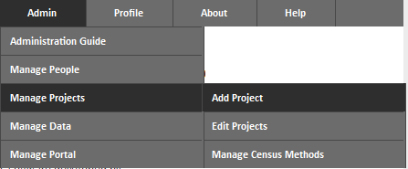

1. The Add Project screen is displayed

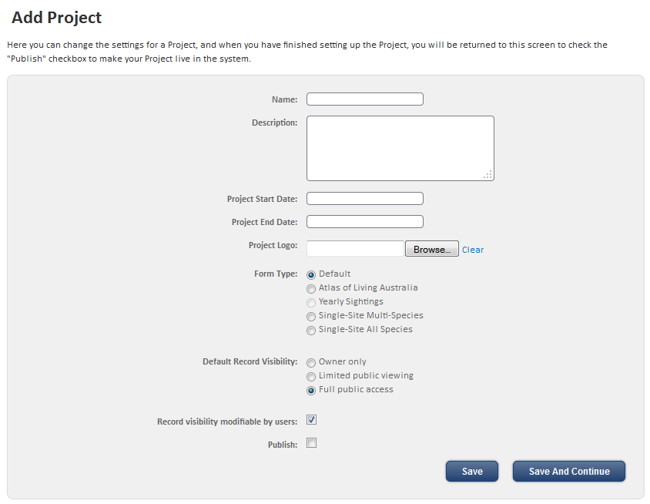

1. Start by entering the **Name** of the project or survey.

Naming is very important because the name of the survey is displayed in the Contribute Menu.

It needs to be self explanatory and short enough to fit into the character limit of 39 characters so your users can find it and distinguish between it and the other surveys on your web site.

Examples:

* Casual Bird Sighting
* Casual Fauna Sighting
* Hollow Bearing Tree Inventory
* Multi-species Sighting form
* Wolli Creek Sighting Location Survey

This example survey is called “Casual Bird Sighting”

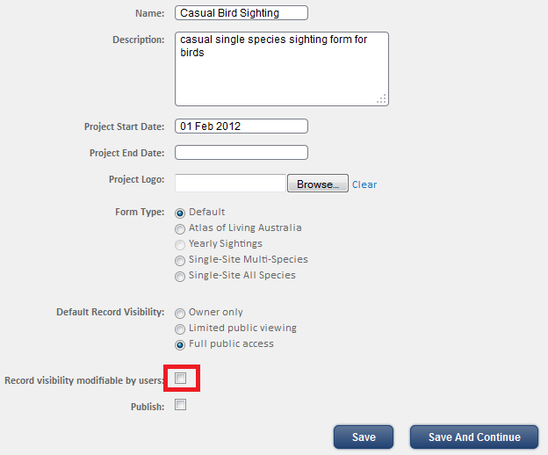

1. Add a **Description**

Like the naming the description should be short and to the point as it may be displayed elsewhere (for example on mousing over a menu item).

In this example it is “casual single species sighting form for birds” which contains several key words or phrases

* Casual; meaning not a formal, expedition based survey following some specific sampling method or protocol
* Single Species; meaning it can only be used to log single species sightings – vs multi-species forms where you can log sightings of …, and
* For birds; and not other species.

1. Add a **Project Start Date** for the survey

**Important** – it’s mandatory, and you can’t add, or import (later), survey records that predate the date you select.

If you need to load historical records into the survey, the survey start date should be **set** to pre-date the earliest record in the dataset.

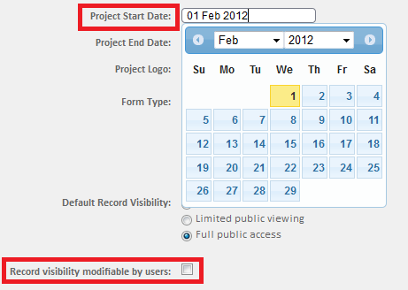

**Aside** - **Project End Date** prevents records being created after the date you set - useful for a fixed period survey.

1. and deselect the **Record visibility modifiable by users**: checkbox

More detail later but basically allows a user to restrict access to a new record until they (or an administrator) publishes it.

1. Click the **Save & Continue** button to proceed to the next step in the **Add** **Project workflow**.
2. The **Choose Taxonomy** page displays as shown

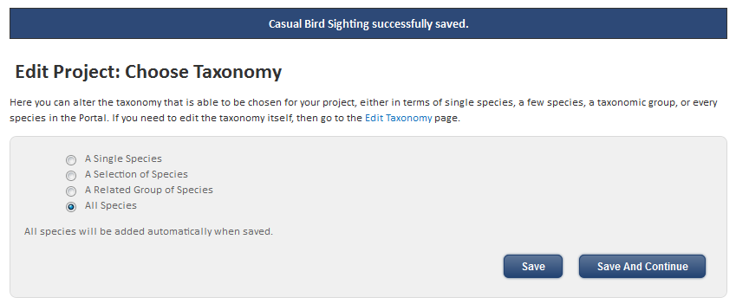

**Tip**

Notice the Blue Message Bar in the above image? It tells you the outcomes of things you have done in the BDRS – like saving things.

It also tells you what’s gone wrong when it doesn’t work!

1. The default taxonomy is all species within your BDRS site but we are creating this as a bird survey so we will choose a related Group of Species then start typing Birds into the species field – selecting Birds when it is displayed.   
   **Note** – “Related Groups” refers to the names used for your field guide taxonomy only and if selected, will include all species which have been assigned to that group(s) in the field guide taxonomy.

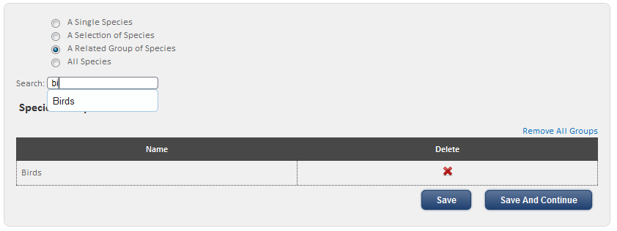

1. Selecting Birds from the auto-complete list automatically adds it into the Species Group list as shown. You can remove it from here or add additional taxon groups.

This is where the naming of taxon group pages and the collections of species within them first becomes important.

1. Click **Save & Continue** to display the Survey form

### Survey Form – Form Builder

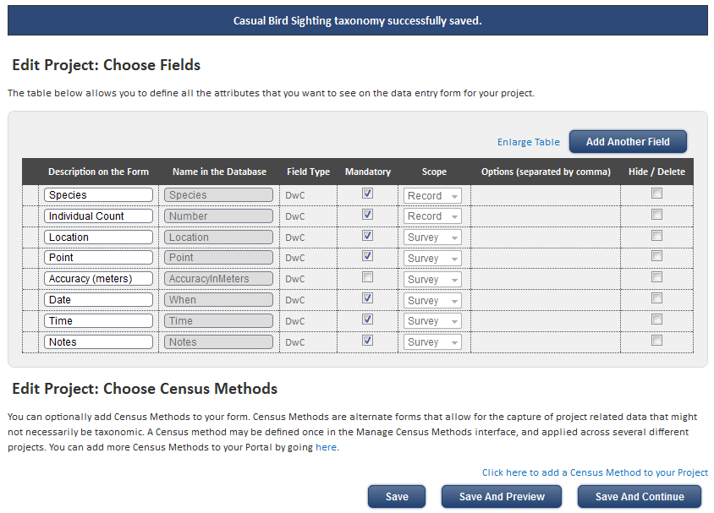

1. The default fields shown are the set of basic Darwin Core (DwC) standard data fields covering the key attributes of any scientifically useful sighting:
   1. What – (positively identified) species
   2. How Many - number
   3. Where – (accurately determined) location
   4. When - date & time, and
   5. Who – user name (provenance – helps determine qualification to make the species determination)
   6. And as much useful information about environmental, climatic, seasonal, sampling methods or other information you can provide in the form of notes that will help make this record even more analytically useful to future researchers.

“The Darwin Core (sometimes abbreviated as DwC) is an international data standard designed to facilitate the exchange of information about the geographic occurrence of species and the existence of specimens in collections.”

Read more about the DwC standard here - <http://wiki.tdwg.org/twiki/bin/view/DarwinCore/WebHome>

1. In the example, we won’t change any of the fields or add new ones using the Add Another Field button but its handy to know that you can:

* **Drag & drop field rows**

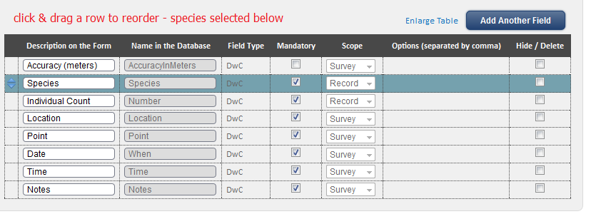

* **Make** a field **mandatory**, and
* **Hide** a DwC field (or **delete** it if you have added one)

**Tips**

DO NOT hide Point – when a user selects a place on the map the latitude and longitude will not display if you hide this field.

DO NOT hide Location – if you are going to create your own preferred locations for a survey and/or allow users to create their own the selection box will be hidden. If there are no locations then this field does not display.

We will ignore the rest for the moment.

1. Click **Save and Preview** to preview your survey (it is not yet completed so don’t save it)

### Survey Form – Preview

This is what the example survey form looks like: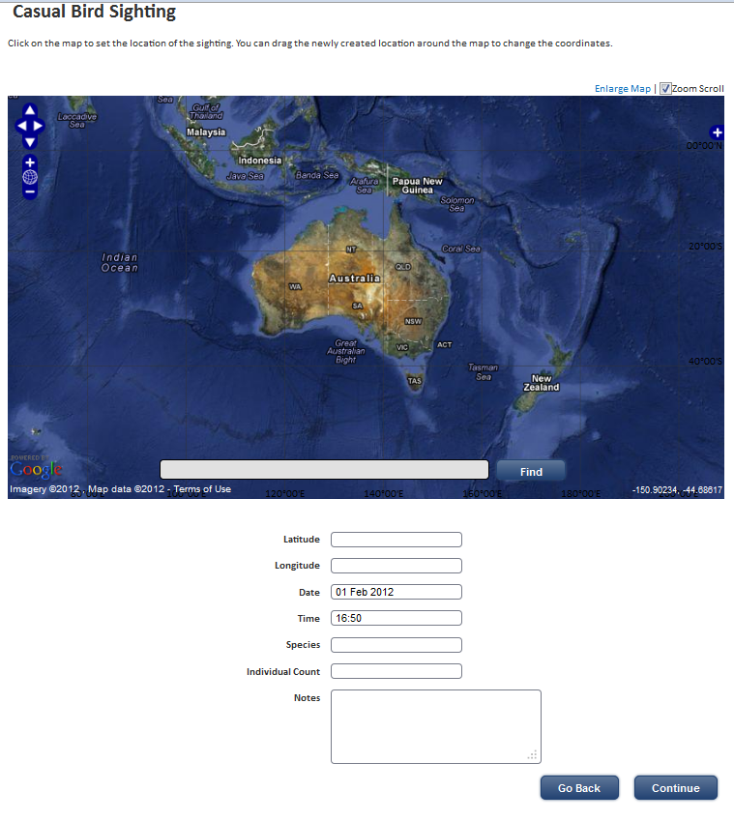

1. As you can see the survey has some basic on screen help above the map and the time & date is preset for you.

Note that you can only perform limited testing of the form now as you can’t submit a record but preview is useful for working on the layout and presentation.

1. Click **Go Back** if you want to change anything or **Continue** on to the Locations Screen

### Survey Form – Locations

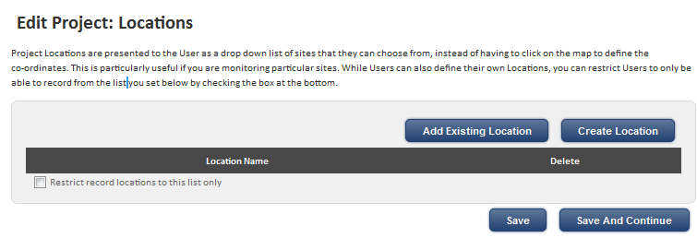

1. Pretty self explanatory and addressed in more detail later. **Save & Continue** to the Access control step.

### Survey Form – Access Control

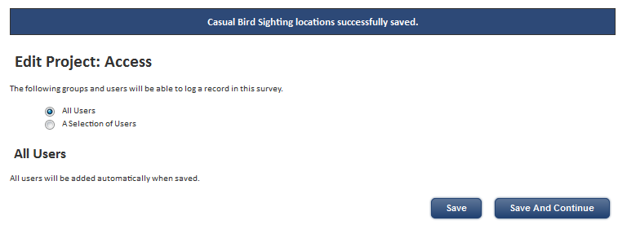

1. Also pretty self explanatory and addressed in more detail later. **Save & Continue** to the Publishing step.

### Survey Form – Final Workflow Step: Publishing

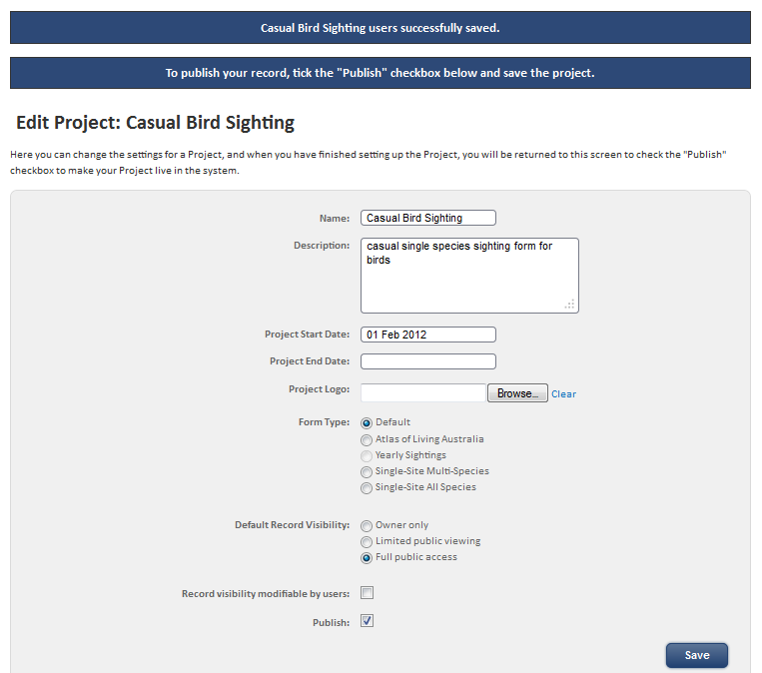

1. Click **Save** to publish your new survey – you should be able to immediately select it on the **Contribute** Menu

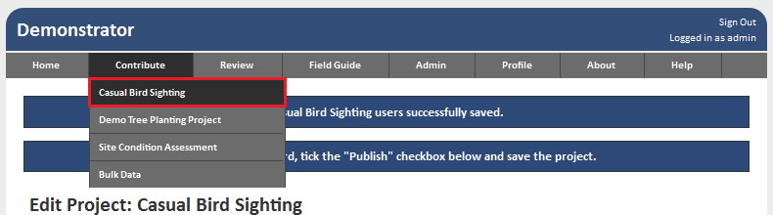

**Tip**

Don’t stop here – go on to the next steps to enhance your survey to make it easier to use and capture more high quality data!

## 2. SIMPLE ENHANCEMENTS & EXTENSIONS TO THE DEFAULT SURVEY

In this section we look at a number of built in features of the tool in order to make the simple survey much easier to use and hence increase the quality of data collected.

1. Log in to your web site as usual.
2. Click on Admin from the navigation menu and Select Manage Projects then Edit Project on the sub-menu to see the list of surveys.

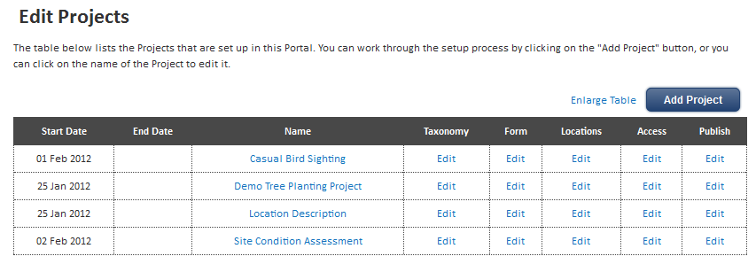

1. Click on the edit link for Casual Bird Sighting survey (your named survey) to edit in the **Form** column.

Notice how the columns – Name, Taxonomy, Form, Locations, Access, Publish – with their click-to-edit links aligned with the workflow steps for Add Project.

1. We are back at the **Edit Project: Form Builder Screen**

### Simple Field Types

1. Start by clicking the **Add Another Field** button

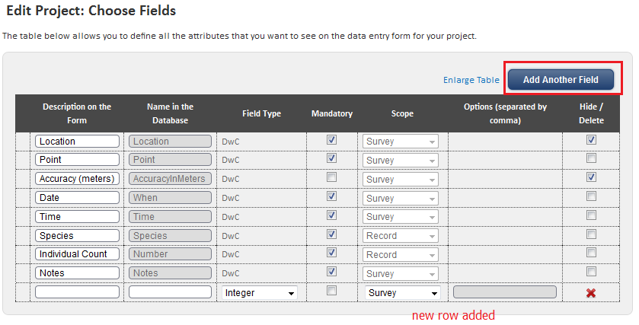

1. Click on the **Field Type** pick list – shows Integer by default

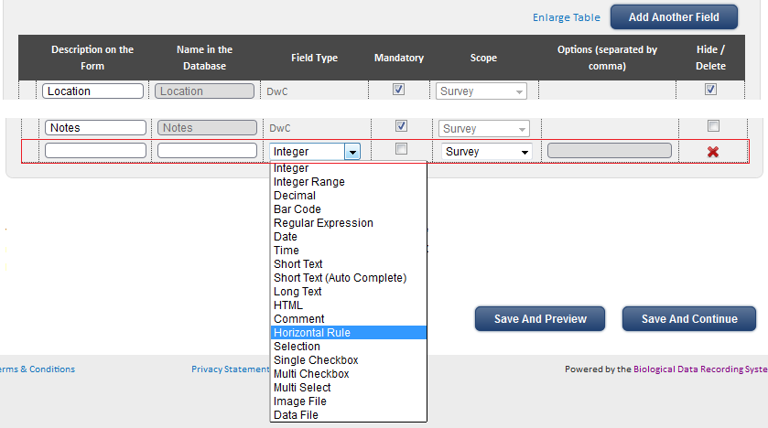

**Note** The **Field Type** options offered in the BDRS include several that have no current functionality – see reference section below.

### Horizontal Rule

1. Select **Horizontal Rule** as shown



1. Description is greyed out as it is not required.
2. Give the Horizontal Rule ‘field’ a unique name (required) – use something self explanatory like HR_1 which uses an underscore instead of a blank space [good practice]
3. In the example the HR has been dragged up between location & dime/date and species based fields to separate them

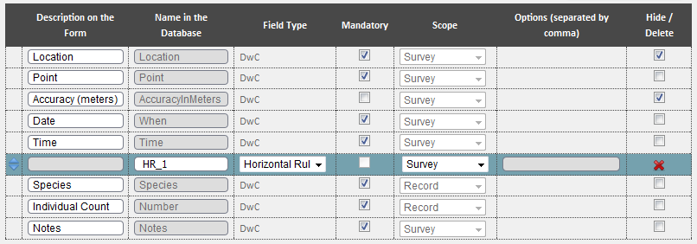

1. Click the **Save and Preview** button

#### Survey Preview Screen

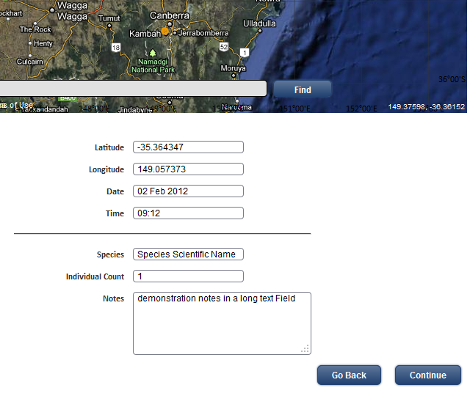

1. Next let’s add some on screen help to advise users what to do in each section - click the **Go Back** Button.

### HTML – On Screen Help

1. Two new field rows of type HTML have been added here to provide help on logging location and species details together with a Selection field for weather conditions.

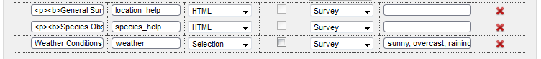

1. To add content to the HTML field click on the **Description on the Form** column element

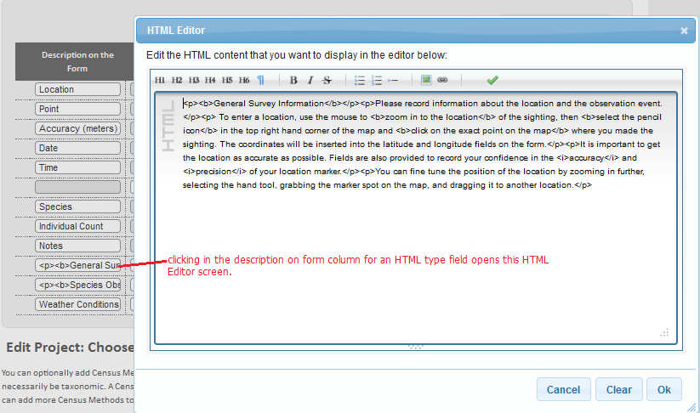

1. An HTML Editor window pops open – type or paste your on screen instructions/help or section title or whatever you want.

The basic editor has buttons across the top for making text bold, italic, into lists, headings and so on.

We recommend that you write the material first then copy and paste text into the screen.

We use free open source tools like Notepad++ <http://notepad-plus-plus.org/> for this and other BDRS development. There are also WYSIWYG HTML editors out there that allow you to write like in Word and then copy the HTML.

**Tip**

Keep it simple – too much text can be too much of a good thing, making simple things look complicated and using up valuable screen real estate on small screens and devices.

1. The example has some headings as visual separators to go with the horizontal rules and a couple of image fields for attaching photos.

#### The ‘Edit ProjectChoose Fields’ screen with simple field based enhancements

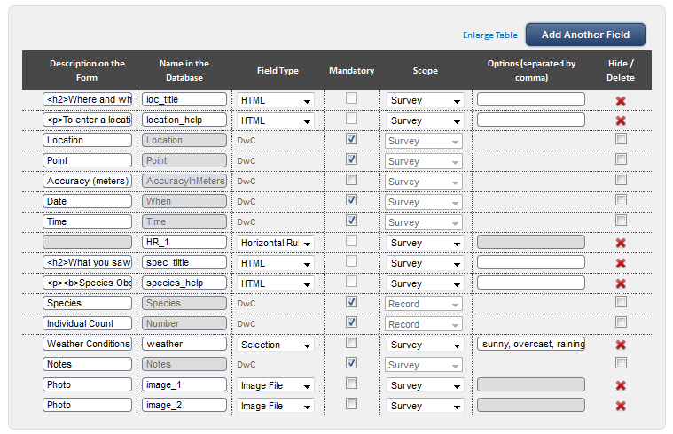

1. **Save and preview** shows:

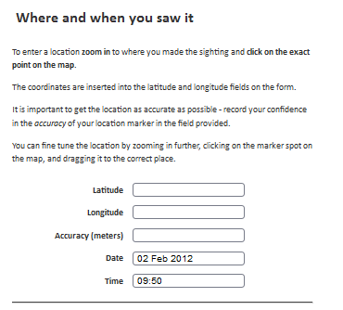

The where and when the sighting was made title and on screen instructions.

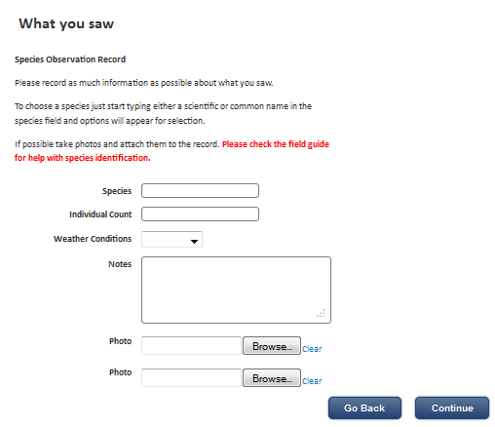

The species sighted title and on screen instructions together with weather conditions and options to add photos as attachments.

Later we will show you how to hide this instruction text when the record is just being read.

### User View - simple field based enhancements to a Basic Survey

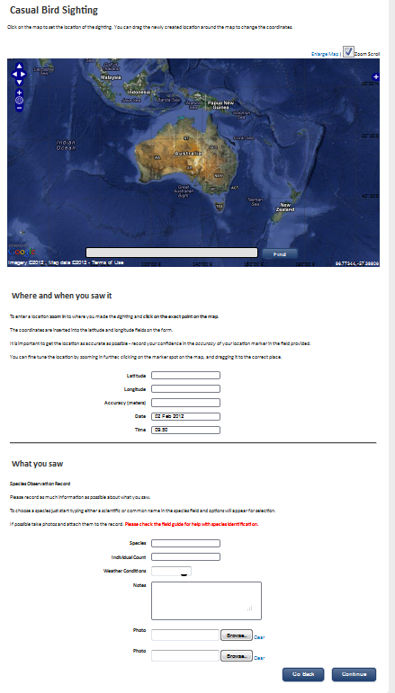

1. With the map it’s become quite a long form already and this is a very simple survey! We haven’t added much in the way of additional information and data fields yet either.

## Field Types Reference

The **Field Type** options available in the BDRS include several that have no current functionality so they are separated in the lists below.

The best way to learn their uses is to play with them – add a field and work your way through the types, saving & previewing to see what they look like and how they function for users.

|  |  |  |  |  |  |  |
| --- | --- | --- | --- | --- | --- | --- |
| Field Type | Description | Image | | | | |
| Integer | None decimal |  | | | | |
| Integer Range | Integer between two bounds | Recommend you add Comment type field explaining your range limit above/below the integer range field so people know the bounds before the error message. | | | | |
| Decimal | Decimal |  | | | | |
| Date | Date Picker |  | | | | |
| Time | Time slider |  | | | | |
| Short Text | Single line, fixed width text field | Can hold more characters (tested > 160) than can display in edit mode.  In read mode displays whole string. | | | | |
| Long text | Multi line, variable width text field  Can drag to change size using dots in RH lower corner. |  | | | | |
| HTML | Valid HTML, CSS and  JavaScript | See examples above.  Adds content in a complete row in the table containing the rest of the form fields. | | | | |
| Comment | Adds plain text to screen in the right hand side comment |  | | | | |
| Horizontal Rule | Horizontal line as a complete row across the table |  | | | | |
| Selection | Drop down list offering single selection from list of options | Choice options    comma separated | | | Display | |
| Multi Select | Drop down list offering multiple selections from a list of options | – using Cntrl key to choose multiples | | | | |
| Single Checkbox | Single check box. Name in Database important for reporting |  | | | | |
| Multi Checkbox | Multi value checkbox displayed inline down the page. | Can select multiple choices | | | | |
| Image File | File attachment of a controlled range of file types (e.g. no executables) |  | | | | |
| Short Text (Auto Complete) | | | unknown function |  | |
| Bar Code | | | unknown function |  | |
| Regular Expression | | | unknown function |  | |
| Data File | | | unknown function |  | |

## 3. EXPLORING SURVEY CONFIGURATION OPTIONS

Here we look at how the basic survey form can be changed and extended using configuration options.

### OPTIONS: FORM TYPE

As you saw in the first exercise survey forms have a number of configuration and other options that we skipped over in the interests of simplicity.

This section explores those options in more detail.

1. Log in to your web site as usual.
2. Click on Admin from the navigation menu and Select Manage Projects then Edit Project on the sub-menu to see the list of surveys.



1. Click on the edit link for Casual Bird Sighting survey (your named survey) to edit in the **Name** column.

Notice how the columns – Name, Taxonomy, Form, Locations, Access, Publish – with their click to edit links align with the workflow steps for Add Project.

In the Edit Project Screen we will work sequentially through the available configuration options starting with form type:

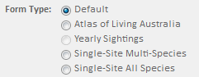

1. Different Form Types present different survey types to users.

We have been using the default configuration which presents the option to choose a single location and a single species.

#### Form Type: Single-Site Multi-Species

1. Select **Single-Site Multi-Species** from the list and click the Save Button

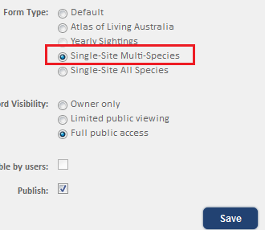

1. Select Casual Bird Sighting (your survey) from the Contribute menu

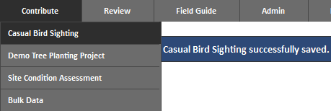

1. And scroll down to the foot of the page.
2. The form type **Single-Site Multi-Species** changes the way you log species sightings from a single organism to being able to add multiple species sighted at the same location in a single survey record rather than having to add them one at a time.

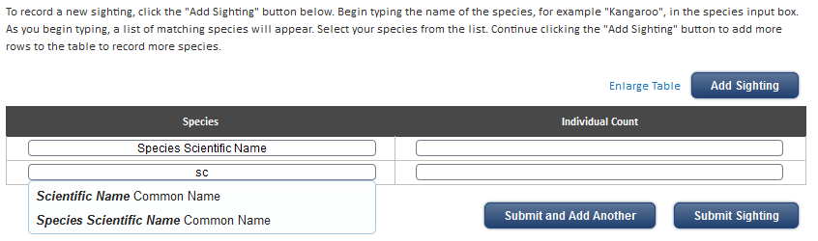

1. On screen help text tells you how to use it. Enter several species and then click the **Submit Sighting** button
2. The My Sightings screen is displayed with this new record shown on the map:

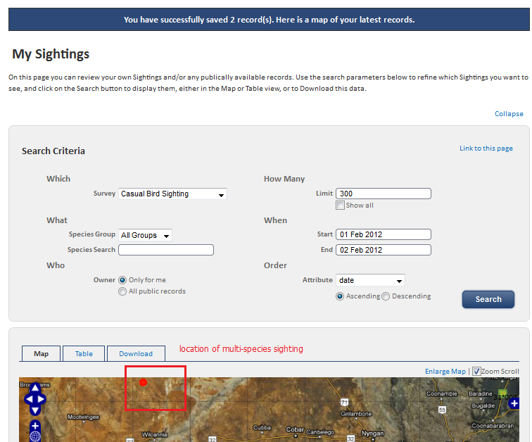

1. Click on the Table tab and you will see TWO entries for the record just created:

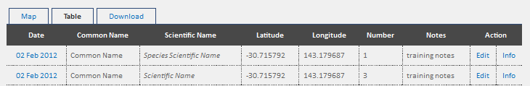

**IMPORTANT CONCEPT**

The two entries are separate RECORDS for the two different species but were created using ONE SURVEY at the single location

If you edit EITHER of these records as displayed you will be editing the SINGLE survey.

If you delete one of the species from the survey its separate record will disappear from the database.

**Note**

You can delete records from the Advanced Review screen. Deleting one of the records from a multi-species survey like this example deletes only that species entry – the others (the survey) remain.

**Tip**

Only add one species sighting at a time – if you make a mistake and add one species row too many there is no easy way of deleting the extra row at the log sighting moment and you cannot submit the survey with an empty species row

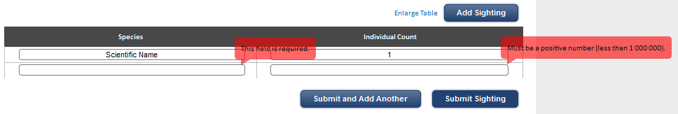

This bug will be fixed in a later release.

In the meantime your other option is add a spurious sighting record for a known species then go to Advanced Review and delete that species record (as explained above) to remove it from the survey and database.

#### Form Type: Single-Site All-Species

1. Select **Single-Site All-Species** from the list and click the Save Button

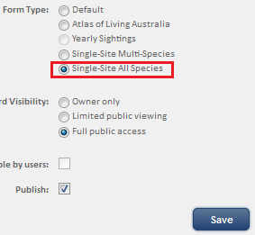

1. Select Casual Bird Sighting (your survey) from the Contribute menu and scroll down to the foot of the page



1. As before the form type **Single-Site All-Species** changes the way you log species sightings from a single organism to being able to add multiple species sighted at the same location in a single survey record rather than having to add them one at a time.
2. The **Difference** is a table of selected species is presented to you against which you add numbers seen.

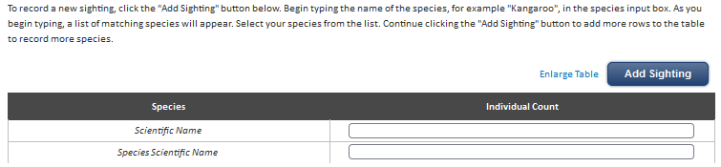

1. On screen help text tells you how to use it.
2. You can add additional different species sightings using the **Add Sighting** button with the same “can’t be deleted once added” caveat that applied to the multi-species form.
3. Clicking the **Submit Sighting** button delivers exactly the same outcomes and reporting behaviours for the **Single Site All Species** form as apply with the **Single-Site Multi-Species** form type so won’t be repeated here.

#### Taxonomy: Setting the Survey Form Species

Closely associated with form type is the taxonomy – in fact we can’t demonstrate the Atlas of Living Australia and Yearly Sightings form types without changing the Survey Taxonomy to a single species – the Yearly sightings radio button option is disabled if you don’t restrict the survey to a single species.

1. Open the Edit Projects screen and select the Taxonomy step for the Survey you are working on.



**Note**

The Atlas of Living Australia form type is not currently available and may be removed (Feb 2012).

1. Select the **A Single Species** option then add the species – start typing the scientific or common name in the search box and select the one you want. The “Species Scientific Name” demo species is shown in the list.

You can only add one unless you choose one of the other options.

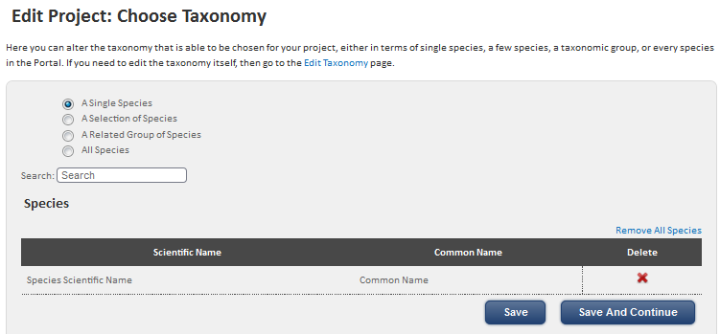

1. Save and then Edit Survey by Title (under Name column)

#### Form Type: Yearly Sightings

1. Select form type = Yearly Sightings and Save the form.

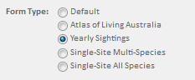

1. Open the survey form from the Contribute menu to see the annual **single species single location calendar** entry form where users can add multiple sightings of the same species by date for rapid data entry.

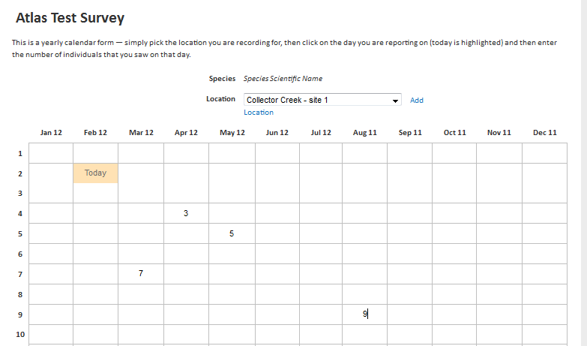

1. As with the other two multiple sightings options multiple records are displayed – one for each date in your table.
2. You can go back and edit the table to add more dates rather than creating more surveys if you like.

### OPTION: DEFAULT RECORD VISIBILITY

Also on the Name step of the Survey workflow are the settings for Record Visibility.

The setting options can be explained with a simple table and couple of images.

|  |  |
| --- | --- |
| Radio button selected | Who can see Records in My Sightings & Advanced Review screens. |
| Owner | The creator of the record and Administrators |
| Limited | The creator of the record, named people & groups associated with the survey via access control, Supervisors and Administrators |
| Full Public | Everyone including anonymous users |

1. Open the Edit Projects screen and select the Name step for the Survey you are working on.



1. Select the **Record visibility modifiable by users:** option

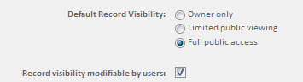

1. Save and then select the target survey from the Contribute Menu

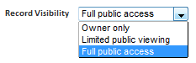

1. One of the possible use cases for this functionality could be where a user logs an uncertain species determination and wishes to do some follow up research to positively identify the species in question before releasing to the public.
2. Another example: records of protected and/or threatened species may only be visible to a more limited membership controlled group. E.g. Birds Australia and Carnaby’s Cockatoo sightings are generally visible but nesting site records are not.
3. By making the record visibility modifiable you allow people with access to change the status. If the control is not visible records created with a particular status will be permanently locked into that status.
4. Summary – record visibility settings control who/which roles can see BDRS records in My Sightings & Advanced Review screens.

### OPTIONS: TAXONOMY

Choosing the Taxonomy to be associated with a survey is simplicity itself – once you have created it in the first place!

The following screen shots are very close to self explanatory.

#### A Single Species

What it says. When a user creates a survey the species field is pre-filled in and not-editable.

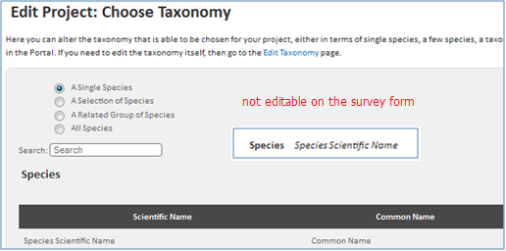

#### A Selection of Species

What it says.

When a user creates a survey the species field (“start typing scientific or common name into the auto-complete field”) provides only those species options you have made available in this part of the survey builder.

Note – This method has it’s uses (especially if you don’t want all species in a taxon group), but can be labour intensive and a potential maintenance issue. Consider using taxon groups instead.

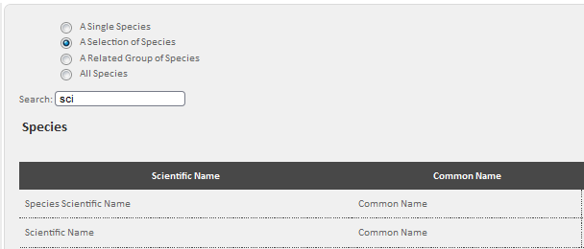

#### A Related Group of Species

Like this:

When a user creates a survey the species auto-complete field provides all of the species within the selected taxon groups.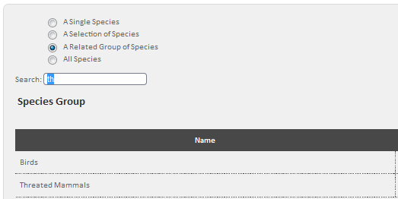

**Note** – “Related Groups” refers to the names used for your field guide taxonomy only and if selected, will include all species which have been assigned to that group(s) in the field guide taxonomy.

#### All Species

What it says. When a user creates a survey they can choose from all of the species in the BDRS.

Because the selection model is the auto-complete field they may have to type a lot of letters to get a usefully short list. There may also be performance problems.

This is particularly so where extensive record level rather than field level attributes are required (explained in the Advanced Survey section)

It would be better to create a taxonomic and survey structure that reduces the range of species to manageable numbers.

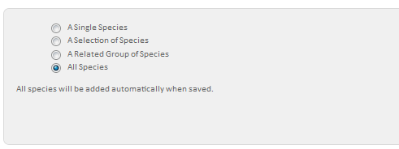

**WARNING**

All species can very dangerous in cases where a) you have a lot species and b) where you have selected form type **Single-Site All-Species**.

This option can crash your browser and even the BDRS server.

### OPTION: FIELDS – THE SCOPE ATTRIBUTE

In the earlier section 2. SIMPLE ENHANCEMENTS & EXTENSIONS TO THE ‘DEFAULT’ SURVEY we looked at adding fields to the survey form to make it easier to use and capture more comprehensive and useful data.

One option overlooked (due to its complexity) in this section was the **Scope** attribute of fields on a survey form.

The complexity is due to scope options only becoming functional when

* the form type is **Single-Site Multi-Species** or **Single-Site All-Species**
* the survey has locations, or
* one of the moderation scope attributes has been set.

A field can be assigned one of 5 scope options:

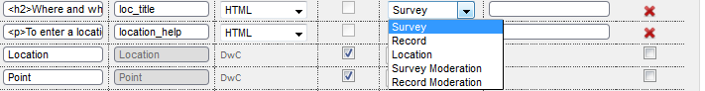

|  |  |  |
| --- | --- | --- |
| Number | Scope Option | Meaning & application |
| 1 | Survey | This field will be maintained and managed at the **survey** and not the record level |
| 2 | Record | This field will be presented and managed at the **record** and not the survey level. |
| 3 | Location | This field will be presented on locations associated with this Survey and data saved with the location made visible in records created with this Survey. |
|  |  | Applying either of the scope options below to a field invokes the built in BDRS moderation process explained in detail below. |
| 4 | Survey Moderation | This field will be presented and managed at the **record** and not the survey level and moderation of all records derived from this survey invoked. |
| 5 | Record Moderation | This field will be presented and managed at the **record** and not the survey level and moderation of the record invoked. |

#### Record & Survey Scope

1. The Casual Bird Sighting form has been edited to change form type to **Single-Site Multi-Species** and some changes made to the form fields as shown here:

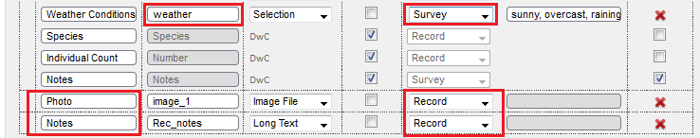

1. The Weather conditions field has been set to scope **Survey** and the two last fields set to scope **Record.** The form now looks like this:

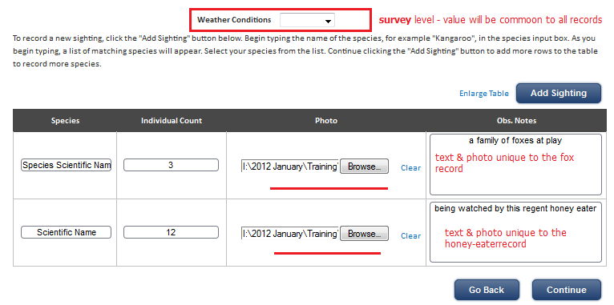

#### Location Scope

1. The two fields **Protection Mechanism** and **Land Tenure** have been added with the **location** scope attribute set



1. The survey Edit Project: Locations screen is opened to display the associated locations

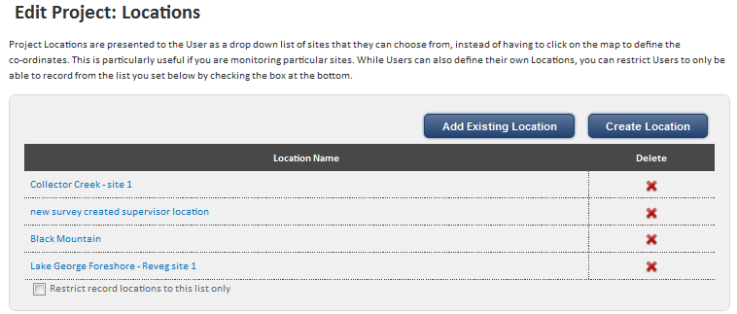

1. You can see the two **SURVEY** fields **Protection Mechanism** and **Land Tenure** with scope **Location** are presented on the Edit Location screen.

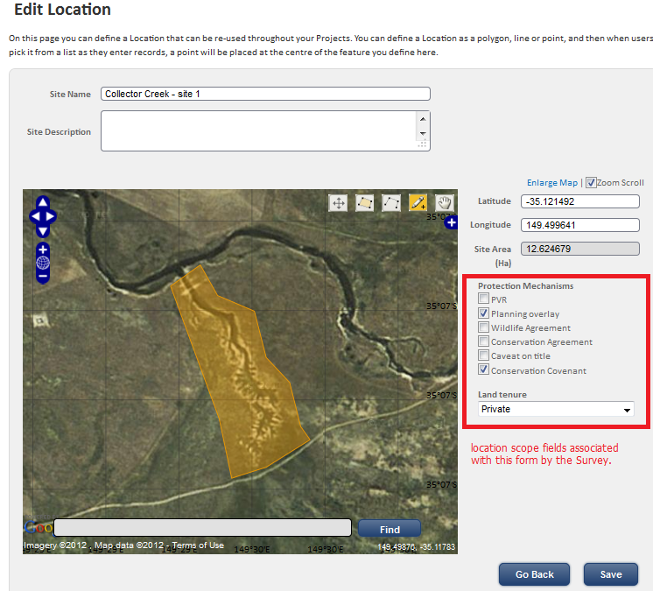

1. Make your changes and then **Save** the location
2. Select the survey from the Contribute menu and select one of the locations you edited

**Example 1**

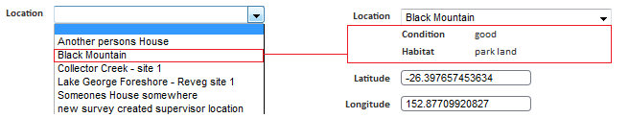

And see the two values you have saved in location added to the selected location on the survey screen

**Example 2 – similarly**

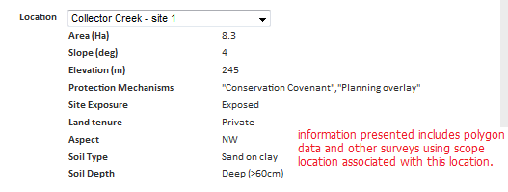

1. The attributes associated with the record are exported with it for analysis.
2. If an administrator changes & saves location scope based values in a location then the new values will be associated with new records.

#### Notes

The potential value offered by the location scope functionality in its current form is a little hard to grasp even with the example used.

Key concept: it is survey not location driven

* the desired fields are set on the survey form,
* then data added to the specific location,
* for inclusion in the records created by the survey form.

The functionality may be useful for displaying invariant or unchanging attributes of a location of the sort shown in the second example – protection mechanism, land tenure.

If you wish to capture non-species information about a location that is changing over time for longitudinal studies you can use the non-taxonomic survey approach described in Census Methods below.

Currently personal locations do not have the same survey driven data fields functionality.

#### Record & Survey MODERATION Scope

Choosing the record or survey moderation scope attributes for a field invokes the built in BDRS simple moderation functionality.

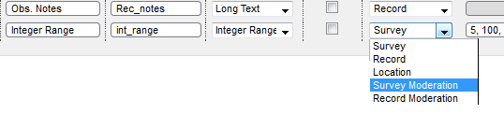

As shown here you don’t need to add a field just to invoke moderation – you can simply change an existing fields scope attribute to the appropriate version i.e. Survey to Survey Moderation; Record to Record Moderation.

You also only need to do it to one field of any Field type.

#### The BDRS Simple Moderation Process

1. When a user **CREATES** a record using a form on which one of the field has a moderation scope attributes then:
   1. The record is automatically marked as **held** when saved.
   2. An email is sent to **ALL** administrators or Supervisors or Root Administrators
      1. in the BDRS site If the survey is public access,
      2. or limited to those configured as users of the survey/project.
2. Visibility of Records
   1. Users can see all of their own records including those being held.
   2. Non Admin Users cannot see the held facet in the advanced review page
3. If you **EDIT** a record which has a moderation scoped attribute
   1. An email is sent as per 1.b above.
   2. The record remains held until released (a separate process).
4. As a moderator:
   1. You can see the "held records only" facet on the advanced review page.



* 1. You have access to the "release" action on the advanced review page.

Selecting this action with records selected will clear the held status from the selected records.

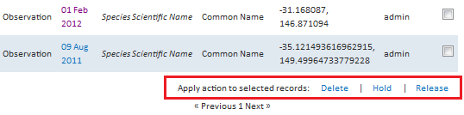

* 1. You have write access to the moderated fields on the survey form.

If you edit one of those fields an email will be sent to the submitter of the record informing them that you have done so.

***Key Concepts***

While you can easily invoke moderation of records using the moderation scope attribute on a field it needs to be properly set up by an Advanced Administrator.

The role of the Supervisor level administrator is just to invoke the general moderation process as required in discussion with a full administrator.

You should also make sure that you have added on screen help/guidance to let users now that this record will be moderated and will not be visible to the public until it has been released (refer to section 2.13).

Moderation is examined in more detail below - .

### OPTION: LOCATIONS

A survey can be associated with specific geographic locations which can include points, lines and polygons.

Locations come in two main flavours – **Personal** and those created by Administrators for **Everyone** to use.

Users can create their own locations with a single map supporting multiple locations - points, lines and polygons - which they can use in surveys where allowed.

At this time you cannot turn a user created My Location into a publically accessible location for other people to use. It’s on the wish list

There is a separate manual covering My Locations so we will focus here on Admin (and Supervisor) created locations.

Surveys with associated locations can either be locked to those locations or open to allow users to use their own locations.

#### Creating and Managing Locations

1. Log in as an administrator
2. Select Admin – Manage Projects – Edit Projects from the menu
3. Select the relevant survey and click on the locations edit option

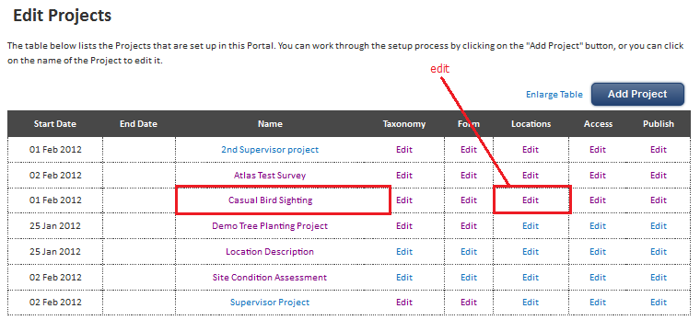

1. The **Edit Project: Locations** screen shows the list of locations applied to this survey and whether the survey allows other locations to be used – the checkbox at the foot of the table

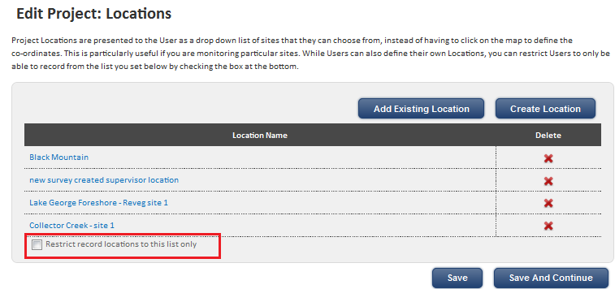

1. To allow users to use their own locations uncheck the ‘Restrict record locations to this list only’ box
2. Click Add Existing Location to select from the available list – you can select and deselect multiple locations

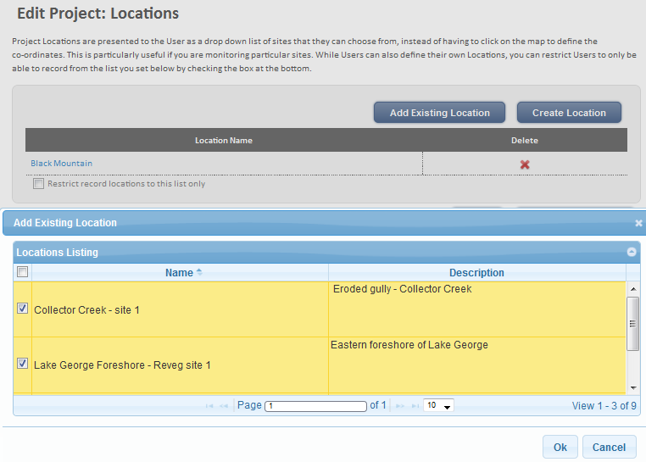

1. Click the Create a Location to open the matching screen. Enter the basic details with the standard note on good names and descriptions.

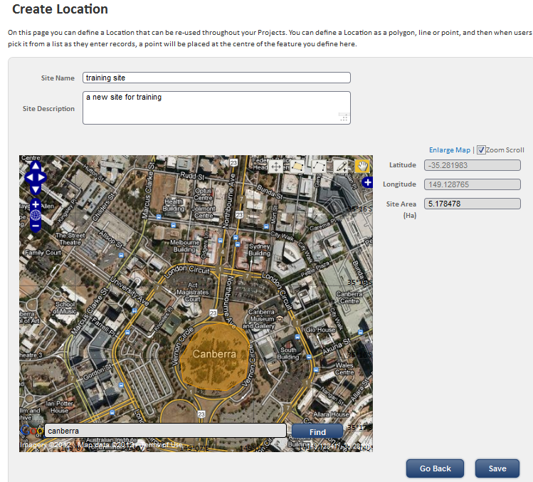

#### Location Editing Tools

1. Tools for adding and editing points, lines and polygons are located in the top right hand corner of the map.

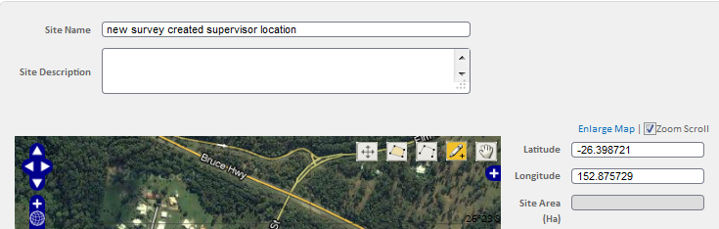

1. Points, lines and shapes (polygons) drawn on a are called map **features**.



The tools all share common characteristics including

* mouse clicks to start,
* double clicks to finish, and
* defaulting back to the drag a feature  mode when completed

|  |  |  |
| --- | --- | --- |
| Icon | Tool Tip | Function |
|  | Select and modify feature | Use this tool to select the map feature to move it or the points it is made up of (polygons & lines) |
|  | Draw a polygon | Polygons can be used to map land holdings, reserves, or any area of interest.  They can be used to set boundaries within which surveys and other activities are to be performed |
|  | Draw a line | Use this tool to draw a line – for example a survey transect.  You can draw multiple lines on a map by reselecting this tool |
|  | Draw a point | Use this tool to draw points  You can draw multiple points on a map by reselecting this tool |
|  | Drag a feature | Use this tool to select and drag a feature |

1. ** DRAWING A POLYGON**
   1. Polygons are created using multiple points.
   2. Click on the draw polygon tool
   3. Click on the map, moving the cursor and clicking again to outline the desired shape

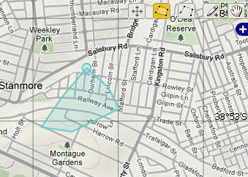

* 1. Double click to complete the shape.

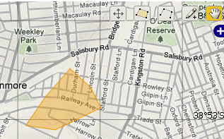

* 1. Give the shape a meaningful name – for example your name, the name of your property, the reserve or other text that makes it easy for you to distinguish between multiple locations of your own (and in a later version, between your and other people locations)
  2. Choose whether this will be the default shape for any survey you are completing
  3. Save the shape

**TIP**

Naming of locations is very important – each location has a name and this name is used to identify the location within the survey so you need to be able to tell them apart.

This will be even more important when you can share your personal locations with others in a later version of the BDRS.

1. **SELECT AND MODIFY FEATURE**
   1. Click on the select and modify tool icon
   2. Click on the feature you wish to modify
   3. This example shows the previously created polygon

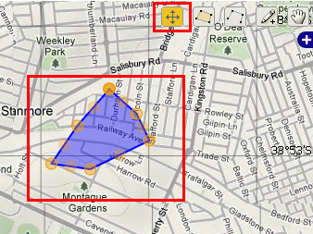

* 1. You can then select the points that make up the feature and drag them to a new location

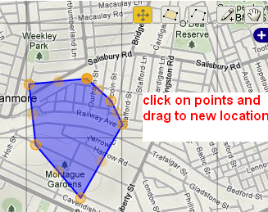

* 1. Save your changes

1. ** DRAG A FEATURE** 
   1. Click on the drag a feature tool icon
   2. Click on the feature you wish to move
   3. hold the mouse button down to drag the feature to the new location

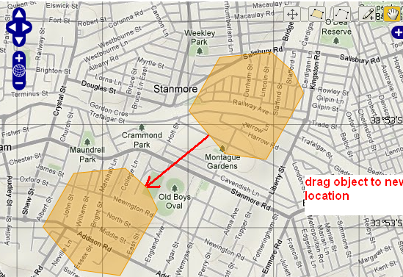

* 1. Save your changes

1. ** DRAWING A LINE**
   1. Lines are created using multiple points.
   2. Click on the draw line tool
   3. Click on the map, moving the cursor and clicking again to draw the desired line

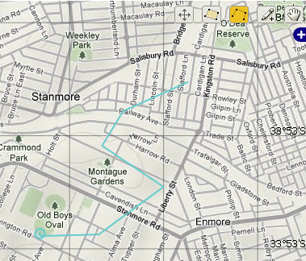

* 1. Double click to complete the line.

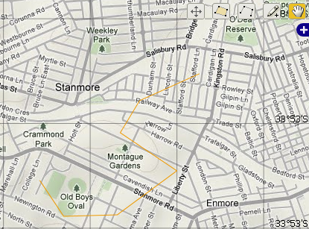

* 1. Save the new line

#### Using Locations

1. Open your survey from the contribute menu
2. Since you already have the Field **Location** in the Survey form the locations you added will be available in the selection list.
3. If the ‘Restrict record locations to this list only’ checkbox has been left unchecked users will be able to use their own locations as well as those created by administrators.

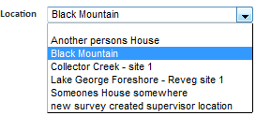

If the box has been checked then users are restricted to only those locations administrators have provided.

Example – the Wolli Creek Preservation Society has 10 locations in their sanctuary that are regularly surveyed with most having records going back 30 years or more. These so called longitudinal or repeating surveys provide invaluable historical data to researchers.

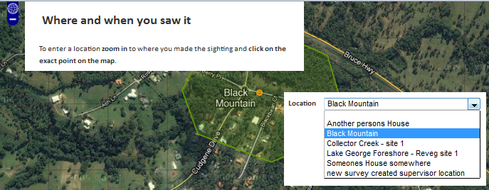

1. Selecting different locations options changes the lat & long values and zooms the map to the new location.

### OPTION: ACCESS CONTROL

Applying access controls to a survey is another simple process you can apply once you have created groups and have users.

Restricting access means that the survey is no longer visible to other users in the Contribute menu and records created with that Survey form are similarly restricted.

The following screen shots are very close to self explanatory.

**Tip**

Use groups rather than users names – you can add and remove people easily from groups in the Manage People area without needing to update all of the surveys that use a particular group.

It is better to create a broader number of well named groups in a flatter structure than having a smaller number of top level groups with a multi-layered hierarchy of nested groups underneath. Particularly difficult to manage when the BDRS does not display this hierarchy – you are then reliant on good ‘stemmed’ naming and memory.

Example of ‘stemmed’ group names – each have birds as the first word implying parenthood.

* birds top
* birds nesting sites
* birds threatened species

Also make good use of the description fields.

#### All Users

What it says.

#### A Selection of Users

The screen shot says it all.

When a user creates a survey the “start typing scientific or common name into the auto-complete field” species field provides only those options you have made available. Labour intensive and a maintenance issue. Better to use taxon groups.

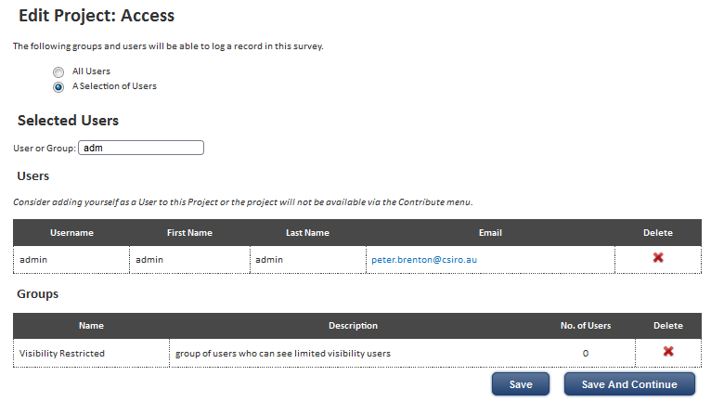

# 4. DEVELOPING MORE COMPLEX SURVEYS

The BDRS provides additional tools not yet explored that further extend the capability and versatility of the Survey.

This chapter reviews two most important ways in which Surveys can be made more useful without requiring any extraordinary web development skills.

They are Non-Taxonomic Surveys and Enhanced Records Moderation.

## 1. Non-Taxonomic Surveys

The preceding material has focused almost exclusively on **Taxonomic** Surveys as they are the mainstay of the BDRS concept, however the system can also support the building of **Non-Taxonomic** surveys (ie. Surveys that don’t use species as records and that don’t rely on the field guide taxonomy being in place).

**BDRS Definitions**

**Taxonomic Survey** – surveys that require a specific species to be identified in each record and for the development of sufficient taxonomic structure (the ‘Field Guide’) for the records to be so allocated.

The latter being a function of the integrated nature of the taxonomy <> survey relationship.

**Non-Taxonomic Survey** – surveys which do not require a specific species to be identified or any particular taxonomic structure to be in place.

**Non-Taxonomic** surveys can be used to make the BDRS a much more flexible management tool - for example it can be used to create data recording forms for a very wide range of site-based non-species specific on-ground activities such as: events (eg. A bioblitz, field day, etc.), remediation/intervention works type activities (eg. Weed management, tree planting, stream restoration, etc.), site condition assessment and monitoring, etc.

Another potentially useful example – supporting the casual ‘**what is it?**’ type survey and situations where there is **no matching species profile** in the BDRS but the user and/or the moderator can positively identify the species.

## Creating a Non-Taxonomic Survey

Creating a non-taxonomic survey is as simple as hiding the “species” and “count” fields on the form and adding the required fields for your data recording requirements in exactly the same as you would for a taxonomic survey.



Alternatively it is also possible to use a non-taxonomic census method type to implement a non-taxonomic survey.

## 2. Census Methods

Census Methods (CM) can be usefully considered to be extension forms for surveys.

They allow you to create a separate, non-survey form using a similar process which can then be added to any survey and so become an integral part of the recording process for that survey. This is particularly useful where you have a basic data collection form that is common to a number of different survey situations, but need to capture different additional data in the different survey situations.

Other uses

* capture data associated with different sampling methods used in collecting different species
* capturing location specific data such as site condition, or tenure & protection mechanism in place
* capturing species identification and other information in situations where the BDRS taxonomy does not include the species in question
* you tell us

#### Key Concepts:

You can associate more than one Census Method with a Survey **but** only **one** Survey:CM combination can be displayed and used to create a record at any one time.

You can create records with a Survey

* with the Census Method fields, or
* without the Census Method fields, and

You **cannot** make the Census Method a mandatory component of a Survey.

When a **Census Method** is associated with a Survey it can **change core Survey Attributes** – specifically it can make a Survey Non-Taxonomic and can also be used to change the mapping options.

When a Census Method is associated with a Survey it is a linear or in-line extension of the Survey form – the additional fields are appended to the survey form.

## Creating a Census Method

You have to create a census method before you can attach it to your survey.

1. Select the Manage Census Methods option from the Admin – Manage Projects menu.

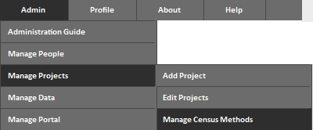

1. To open the Manage Census Methods screen

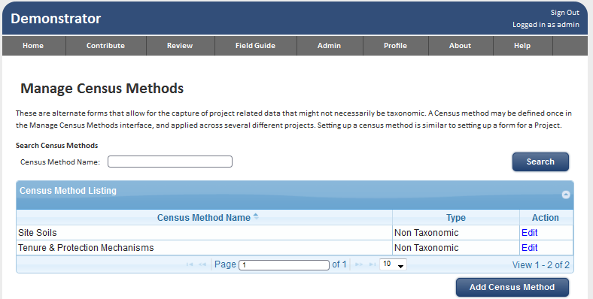

1. Click the Add Census Method Button

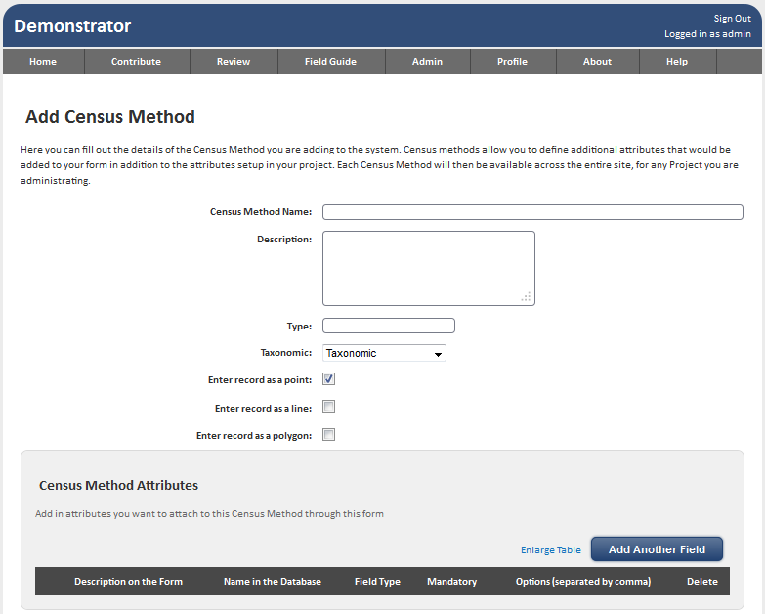

**Note**

The option to add Sub Census Methods will not be addressed.

#### Configuring the Census Method

1. Close up of the fields on a Census Method form

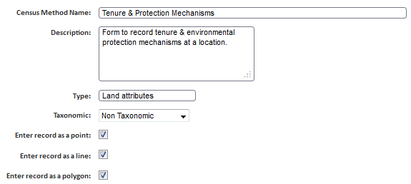

1. **Census Method** **Name**
   1. Enter the title into the only mandatory field in this form, following good naming and descriptive practice as always.
2. **Type** 
   1. Optional. May be able to use in reporting tools in later BDRS versions.
3. **Taxonomic** – CRITICAL
   1. This is where the Non-Taxonomic (non-species) attributes for the Census Method and its associated Surveys is set.
   2. Three options:
      1. Taxonomic (default on new Census Method)
      2. Non Taxonomic
      3. Optionally Taxonomic

If either Non Taxonomic OR Optionally Taxonomic is selected then the three species related Darwin Core fields on the survey form can be disabled by hiding them:

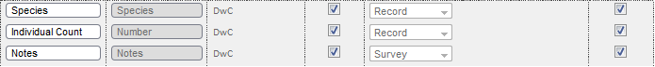

1. With Optionally Taxonomic surveys can be made species independent or not on a survey by survey basis.
2. The next three check boxes allow you to add tools to the **Survey Map**.
   1. Enter a record as a point:
   2. Enter a record as a line:
   3. Enter a record as a polygon:

By default a user can select a location for a sighting using one of two methods – either clicking on the map to create a point or selecting a pre-existing location and having details populated automatically.

In the section on **Locations** above users are provided with more map tools than on Surveys



1. You can use the selection options to provide each tool type to users of the Survey:CM combination so they can, for example, draw a polygon around weeds or groundcover.

#### Census Method Attributes

1. You can add fields to the Census Method form using same interface options and methods used in Survey forms.

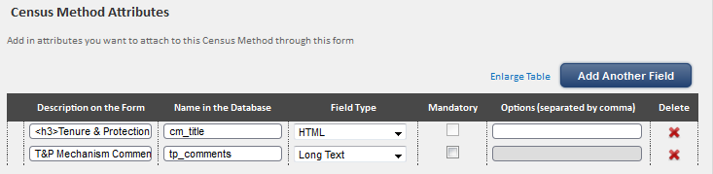

1. In the example we have added a horizontal rule and simple HTML heading and a comments field so you can see how they present on the survey form.
2. Save the Census Method form.

## Adding Census Methods to Surveys

1. Select the Survey you are going to add the Census Method to and Edit the FORM step of the workflow.

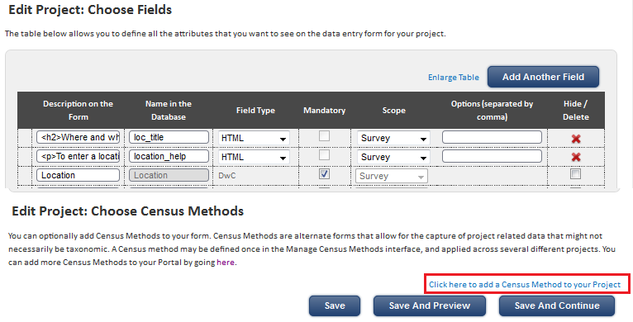

1. Click the  hot spot at the bottom of the screen and scroll down to reveal the Add Census Method option

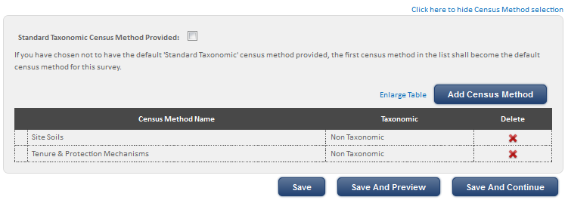

1. The example shows two Census Methods have been added to the Survey using the standard BDRS “Add Something” button – self explanatory
2. Test the Survey form in the Contribute menu.

#### Survey Form Showing the Census Method Changes

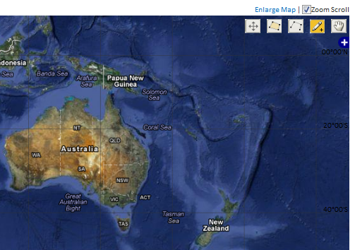

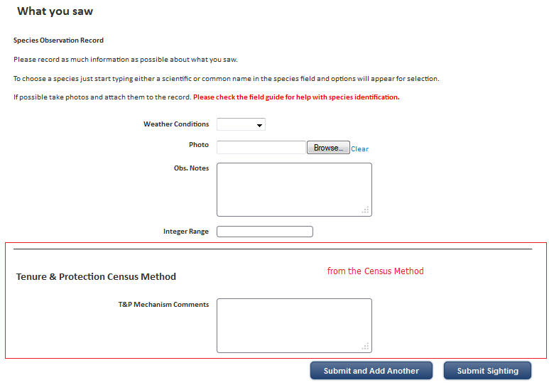

***Key Concepts Demonstrated***

A **Census** Method can **change core Survey Attributes** – specifically it can make a Survey Non-Taxonomic and can also be used to change the mapping options.

#### Menu Changes Associated with Census Methods

Finally when a Census Method is associated with a Survey it is a **linear** or in-line extension of both the Survey **form** (where the additional fields are appended as seen) AND the **Contribute** Menu

1. The Contribute Menu includes BOTH of the Census Methods added to the Survey as extensions of the Survey Menu selection item:

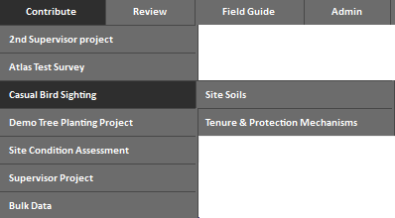

1. You can Select **either** Casual Bird Sighting + Site Soils **or** Bird Sighting + Tenure & Protection Mechanisms

If you click on Casual Bird Sighting you will get the ‘naked’ Survey without either of the two of its associated Census Methods

1. If you think people may not know you can do this tick this box and Save the survey form

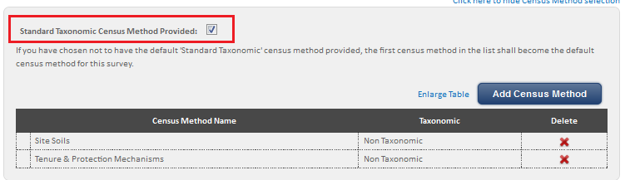

1. The menu will now look like this:

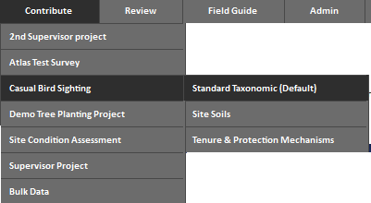

1. Making the Default no Census Method Survey option much more obvious.

## 2. RECORDS MODERATION – THE DETAILS

From Version 1.0 the BDRS has a simple built in moderation capability. Prior to this we used web development techniques to implement a pseudo moderation capability.

Previously in this manual (see ) we briefly described the simple built in capability in terms of emails sent on creating and editing but not how the complete package hangs together. This section explores it in more detail

***Note***

We consider the ability to easily and effectively moderate records for quality management to be a core requirement for the BDRS and will continue working to enhance this significant capability.

### The Survey Form: Create & Edited

1. The survey form has a field with scope attribute of moderation as described previously.

In the next software release two new field types will be added to the form builder Field Type selection list:

* Created BY & Created TIME/DATE, and
* Last Modified BY & Last Modified TIME/DATE

You can add these fields to the form in the same way you can add a horizontal line.

We recommend that you add on screen separators & help/guidance text to the survey form to advise users that records created with this form will be moderated and will not be visible to the general public until released.

***Notes***

The new fields allow you to see information already captured by the BDRS but currently not displayed in the record – who originally **created this record** and **who last edited it**

They are both necessary attributes of an audit trail and of interpreting the content of record – e.g. :

Does this user have the experience needed to identify this species in these circumstances?

But they are also core requirements of a moderation process – Who created it? Who moderated it and confirmed/denied the species determination; and who released the record into the public domain for all users to see?

### The Survey Form: Actions on Submit

1. When a user **CREATES** a record using a form on which one of the field has a moderation scope attribute then:
   1. The record is automatically marked as **held** when saved.
   2. An email is sent to **ALL** administrators or Supervisors or Root Administrators
      1. in the BDRS site If the survey is public access, or
      2. limited to those configured as users of the survey/project.

Example of the email sent to administrators

Hi <SUPERVISOR/ADMINISTRATOR NAME>,

I've just logged a record in <SITE NAME > that requires your attention, as it is logged against a survey with moderation turned on, and you are a designated administrator.

The details of the record can be found [here](https://vic.owa.csiro.au/owa/redir.aspx?C=6ebe51f22fe249c78fb31ec12e6c7d75&URL=http%3a%2f%2fbdrs-uat.ala.org.au%2fbdrs-core%2fportal%2f14%2fbdrs%2fuser%2fsurveyRenderRedirect.htm%3fsurveyId%3d51%26recordId%3d11304)

If you edit the moderation fields, the system will email me back to let me know that there has been a change, and then I can make any edits. The system will continue to send links back and forth until the record is released.

If you want to approve this record for release, then you need to go to the Advanced Review page, look at the record in the List view, and mark it for release that way.

You can access the Advanced Review page by going [here](https://vic.owa.csiro.au/owa/redir.aspx?C=6ebe51f22fe249c78fb31ec12e6c7d75&URL=http%3a%2f%2fbdrs-uat.ala.org.au%2fbdrs-core%2fportal%2f14%2freview%2fsightings%2fadvancedReview.htm%3f0_user%3d-1%260_held%3dheld)

Thanks!

<USER NAME>

As you can see the default email content explains what is going to happen – and that it needs some work.

You can edit the email content for both user and moderator by going to Manage Portal – Edit Content on the main menu

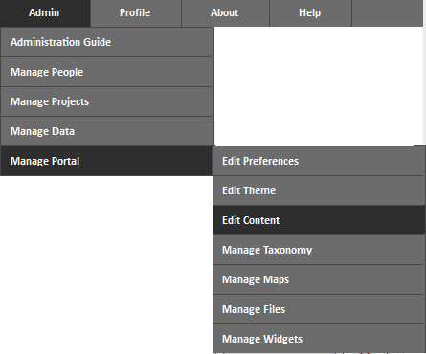

And editing email/Moderation Required & email/Moderation Performed content.

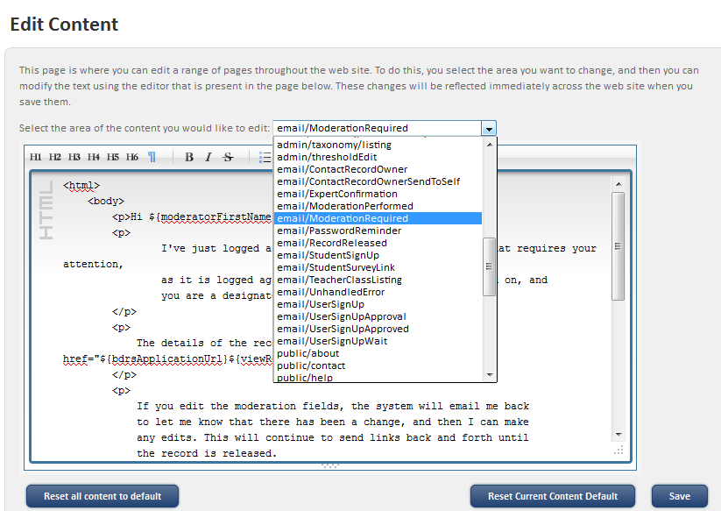

### The Records: Visibility & Locking

1. Visibility of Records
   1. Users can see all of their own records including those being held.
   2. Non Admin Users cannot see the held facet in the advanced review page

***Notes***

In the next release a **Held** status indicator will show the record is not yet public both in reporting views and when reading the record.

1. Records are **Locked** in a read only mode until unlocked by an authorised person – the creator, supervisors and administrators.



***Notes***

This locking in read mode is the first step towards full anonymous public access to records content in the next release.

1. Clicking on the Padlock link unlocks the record for editing

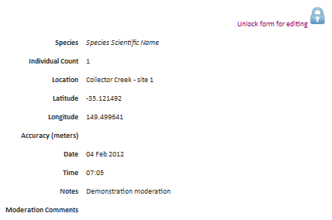

1. The same record in Edit mode

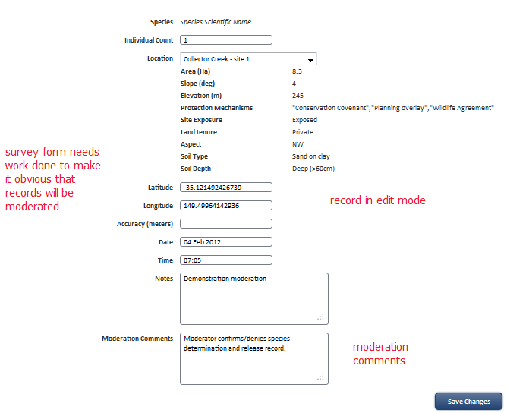

1. If you **EDIT** a record which has a moderation scoped attribute
   1. An email is sent as per 1.b above.
   2. The record remains held until released (a separate process).

### Releasing Records: Moderator

1. As a moderator:
   1. You can see the "held records only" facet on the advanced review page.



* 1. You have access to the "release" action on the advanced review page.

Selecting this action with records selected will clear the held status from the selected records.



* 1. You have write access to the moderated fields on the survey form.

If you edit one of those fields an email will be sent to the submitter of the record informing them that you have done so.

# 5. IMPORTING RECORDS

The BDRS allows Users with Administrator privileges to bulk load data into the system using an ExcelTM spreadsheet. The process can be temperamental so it is important to follow these instructions exactly.

The basic process is as follows:



**TIP:**

It is important that you use the downloaded XLS template as it will contain all of the relevant fields with established mappings to the database (important when you come to upload the completed spreadsheet).

## Pre-requisites:

* All surveys which include species observations must have all of the species in the dataset loaded into the BDRS taxonomy, otherwise the load will fail. (see Creating taxon groups and Creating taxon pages for how to do this)
* All of the data to be loaded must have a corresponding field included in the BDRS survey form before downloading the form template. (See Creating a BDRS survey)
* Locations must have already been created in the BDRS and associated with the relevant survey (see notes on how to create locations).   
  **NB.** If the locations in the dataset are just a collection of point locations defined by latitude and longitude values, establishing pre-defined locations is not necessary. (Note: Lat/Long values must be in WGS84 decimal format).

## How To:

### Create Survey Form

1. See **Creating & Managing Surveys**.

**TIPS:**

1. Minimise the number of mandatory fields in the form. If you try to submit the data spreadsheet with null (blank) values in a mandatory field, it will fail to load.
2. Ensure that all locations (where they are pre-defined) are created and associated with the survey. These will appear in a Locations tab in the data spreadsheet template. If you have locations in your data which are not in the Locations tab of the data spreadsheet, it will fail to load.
3. Ensure that all species recorded in the data have species pages in the appropriate taxon groups before downloading the data template. These will appear in a Taxonomy tab in the data spreadsheet. If you have species in your spreadsheet which are not in the Taxonomy tab of the data spreadsheet, it will fail to load.

### Download the Form Template

1. In the BDRS, goto the Admin > Manage Data tab and select “Bulk Data Loader”.

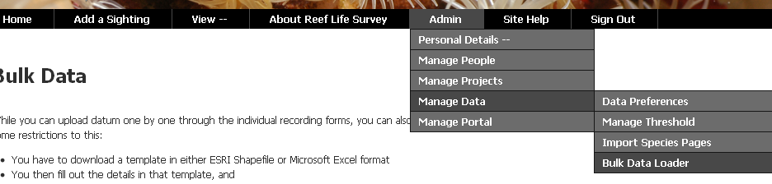

1. Select the relevant project (survey) and click the Download template button.   
     
   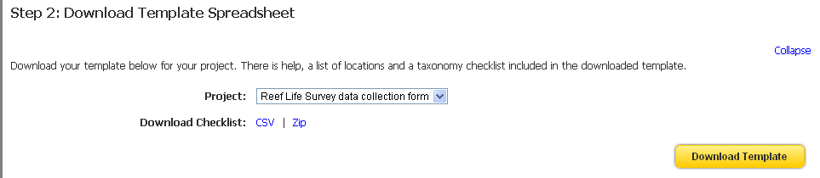  
     
   You may be prompted to select a program for the spreadsheet to open into. This will then open the spreadsheet with each form field shown as a column heading on the Data sheet (Observations tab).   
     
   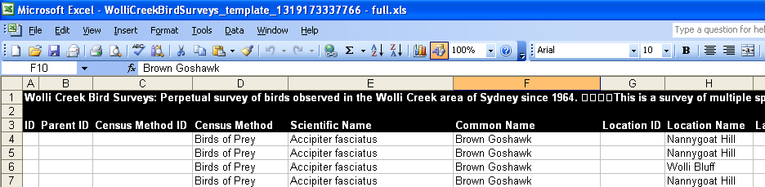  
     
   Note the tabs on the spreadsheet (see Tips above)  
     
   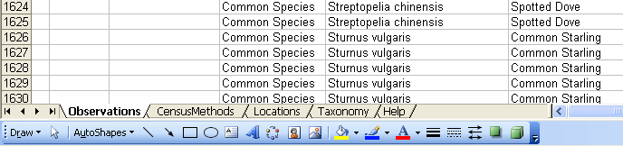

### Populate the Form Template

1. You can populate the form by either manually entering a row for each record, or by copying and pasting columns of data from an existing spreadsheet.

**TIPS:**

1. If you have an existing spreadsheet with data to import into the BDRS, copy and paste data in columns from this sheet into the appropriate fields in the form template.
2. All mandatory fields in the form template must have a valid value or the upload will fail.
3. Ignore columns A-D in the Observations tab.
4. Date fields must be entered in or converted to the correct format – ie. dd/mm/yyyy
5. Time fields must be entered in or converted to the correct format – ie. hh:mm:ss AM
6. The location in the Observations tab can be either a named location (if the coordinate has a named location associated with it), or a WGS84 decimal Latitude/Longitude value.
7. The species name entered in the Observations tab can be either a scientific name or a common name if the scientific name in the Taxonomy tab has a common name associated with it, otherwise it must be the scientific name only.
8. For taxonomy and locations, spelling and numerical values must exactly match between these tabs and the Observations tab.

**NB.**

* + You cannot add, remove or move columns in the spreadsheet. If you need to modify these at all you should return to the survey form in the BDRS and edit that, then repeat from Step 2 above.
  + You should not change the name of the spreadsheet other than to remove the “Copy of” prefix text that is often appended to the front of the file name on save by Microsoft ExcelTM.

1. Check the following:

* All mandatory fields in the form template have valid values for all records
* All dates and times are in the correct format.
* All locations in the Observations tab have a corresponding named location and WGS84 decimal Latitude/Longitude value in the Location tab. Spelling and numerical values must exactly match between the two tabs.
* All species listed in the Observations tab have a corresponding species name and, if applicable, common name in the Taxonomy tab. Spelling must also exactly match between the two tabs.
* All species listed in the Taxonomy tab must have a taxon group associated with them.
* All taxon groups and all species listed on the Taxonomy tab must exist in the BDRS.

1. Save the completed form template to your local drive (where you can find it again), ensuring that the file name is exactly the same as it was when downloaded.  
   [**NB**. Sometimes Microsoft ExcelTM will append “Copy of ..” as a prefix to the file name].

### Upload the Form Template

1. In the BDRS, goto the Admin > Manage Data tab and select “Bulk Data Loader”.
2. Select the relevant project (survey)
3. Browse to find the completed form template file and click “Upload spreadsheet”.

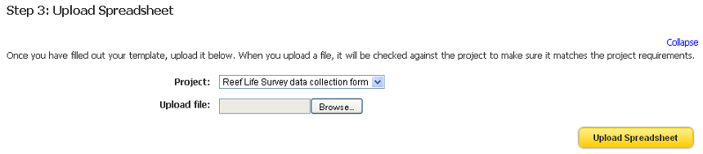

1. The upload process may take a while, but when completed should indicate a successful load.

**NB. (VIP)**

* + Do not reload the same records in either the same spreadsheet or a different one without first checking the data load (see below) to see whether they loaded successfully, regardless whether an error message displays or not. Sometimes you will get an error message on the load, but all or most of the records will have actually loaded successfully. If you try to reload, you will likely get duplicate records. These cannot be easily deleted.

### Check Data Load

1. Count the number of records (rows) in your upload spreadsheet.
2. In the BDRS, goto menu item “View Records” and select either “My Sightings” or “Advanced Review”.
3. If “My Sightings”, select the appropriate survey, owner, and date range for the records of interest.
4. If “Advanced Review”, filter the data using the facets to show the relevant survey, contributor, and dates applicable to the survey records in your upload spreadsheet.
5. For both steps 13 and 14, click on the “Table” tab. At the bottom of the page will be a record count for that dataset. This should match the record count in the upload spreadsheet.
6. If the record counts differ, then further investigation of the data is required – see Troubleshooting below.

### Troubleshooting - What can go wrong?

If you are experiencing problems with data loading, please work your way progressively down the following list of potential issues.

|  |  |  |
| --- | --- | --- |
| **Problem** | **Cause** | **Remedy** |
| The required survey is not available in the drop-down list | The survey has not been made public | The Administrator must check the “Publish” flag on the survey. |
| The spreadsheet template does not have all of the fields that I need for my data | Required fields have not been added to the online survey form. | The administrator must insert the required fields into the survey form. See Developing a survey. |
| Error loading the spreadsheet | A scientific name or common name in the data tab spreadsheet is not in the Taxonomy tab. | Species must be recorded in the BDRS for it to be able to accept a species name.  See: Importing Taxa  **NB.** Spelling of names must be identical between the Data and Taxonomy tabs |
| Error loading the spreadsheet | A named location or coordinate in the data tab spreadsheet is not in the Location tab. | Named locations and corresponding coordinates must be in the BDRS for it to be able to accept a named location.  **NB.** The character strings for both named locations and coordinates must be identical between the Data and Location tabs. |
| Error loading the spreadsheet | Data loading process times out. | Break the data into multiple workbooks.  **NB.** The file name should remain the same, so on each successful load, save the file as version 1, then replace the data with the next batch, load, and save as version 2, etc. |
| Mismatch in record count between spreadsheet and loaded records | Some records load and some fail to load. | Thoroughly check the data to determine which records in the dataset did load. Remove these from the upload spreadsheet and try to reload the subset that did not load successfully.  **NB.** If it fails a second time, contact the system administrator. |

# 6. REPORTING

### BDRS On-line

My Sightings

Advanced Review

### Atlas On-line

Regions

ALA general

Spatial portal

Direct

Import/export

### Exporting

Downloading record sets

Current limitations & plans

# APPENDIX A: DEVELOPER CODED MODERATION

This section describes a moderation process implemented in the browser front end of the BDRS.

It is retained as it describes a moderation use case.

## Introduction

This document describes the simple moderation process that can be added by a trained administrator to any survey in an instance of the Biological Data Recording System (BDRS)

The process of modifying a survey to support moderation is described in another document.

## Requirements

**Administrators**

Administrators should understand the relationship between species profiles and the lists of species that a user can select from in a taxonomic survey.

The relationship is explained in this document.

**System**

The BDRS taxonomy must include Uncertain and Not-Listed (or the administrators preferred equivalents) as species types that a user can select in a taxonomic survey.

This document shows how these options can be selected and what the moderator is able to do with these choices to achieve the desired outcomes.

## Basic Process

Summary of the process:

1. User logs a sighting and selects either Unidentified/Uncertain or Not-Listed
2. User enters the name of a species that is either what they think they have seen, or as a request for that species to be added to the selection list.
3. Moderator reviews sighting and either confirms/denies tentative identification and/or adds a new species profile into the BDRS.
4. Moderator may not be able to positively ID the species sighted.
5. In case where Moderator can positively ID species and the required species profile is available Moderator selects correct species, comments on decision and submits confirmed ID.
6. In case where Moderator cannot ID species Moderator leaves selection as Unidentified, comments on decision and submits record.

## 1: USER LOGS A SIGHTING

#### Instructions:

1. Open the provided link to the website.
2. Click on the Sign In menu item

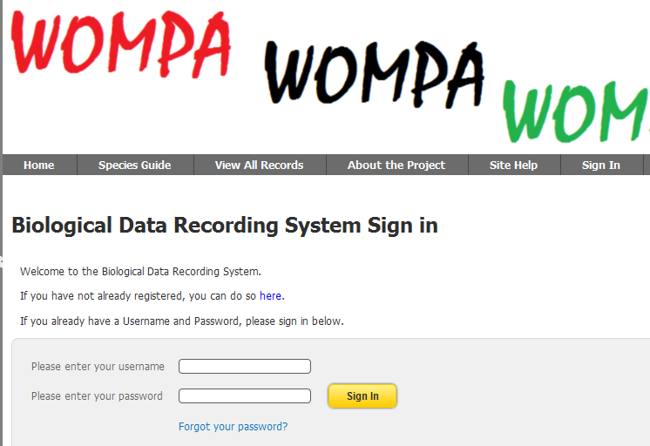

1. Select Add a Sighting on the menu and choose Simple Sighting

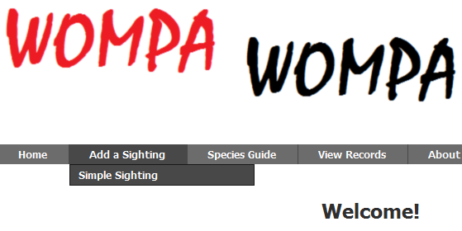

1. The simple sighting form is displayed.

For the purposes of this moderation section we will step over the General Survey Information and Latitude and Longitude sections to the

1. **Species Observation Record** section

You will notice there are instructions for the user on the screen.

They state that if the user does not know, or is uncertain, of the species they are logging then they should type **Unidentified** into the Species auto-complete field

If they believe they can identify the species but cannot find it in the Field Guide (note: there is a link that opens the field guide in a new tab window providing access from the survey) then they should type **Not Listed**

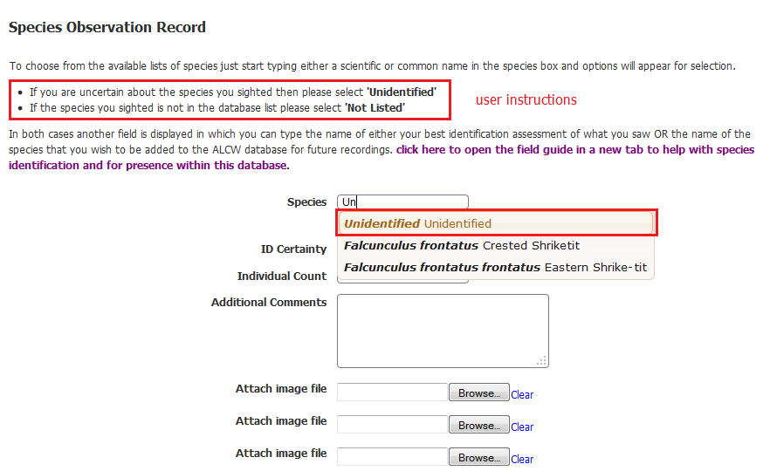

1. When a user types and selects either **Unidentified** or **Not Listed** then a new field is displayed labelled “possible species identification”

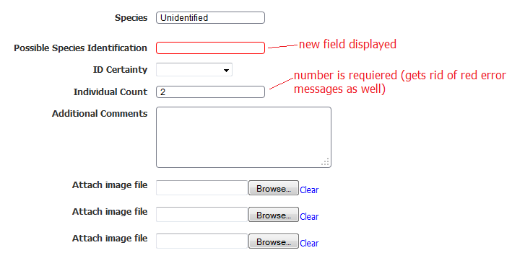

1. The user should then type in their identification – either possible or actual if they are requesting a new species profile be added to the list.

There are several ways in which these options as presented could be interpreted by users:

* 1. If the user has **not** checked to see if there is a profile present for this species in the *field guide* then they may choose **Unidentified** or **Not Listed**
  2. If the user has checked the *field guide* and they cannot find the species they may choose **Unidentified** (example below)
  3. If the user has checked the *field guide* and they cannot find the species they may choose **Not Listed** (expected behaviour)

The interpretation of *the term field* guide used in these cases adds further complication – the user may have in fact browsed the actual field guide, or they may simply have typed a common name into the auto-complete field.

Both can be misleading – the BDRS present species with a known scientific name but only a single common name (unlike the Atlas of Living Australia) and so a species may in fact be present under a different common name or with a non-representative or too different image/s.

These permutations make the task of the moderator more difficult.

*Reader – we may need to change the way this works – perhaps making the choice obvious: choose from the guide/list OR just type away and “we” will do the work for you.*

1. The user completes logging the sighting and saves the form.

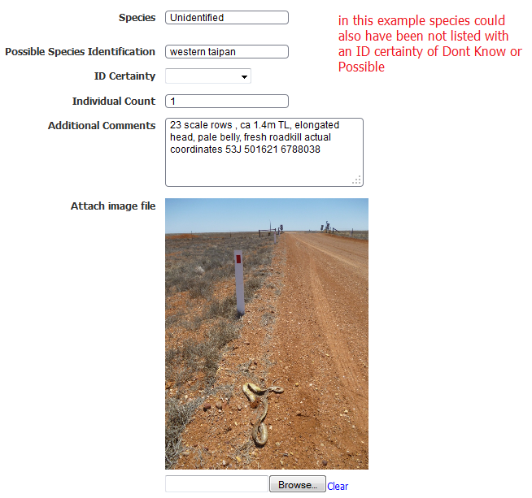

Example where ID appears positive but Unidentified has been selected

## 2: THE MODERATION PROCESS

The basis of this simple moderation process is what each user can see and interact with on the survey page.

The bottom section of the survey page is different for a standard user

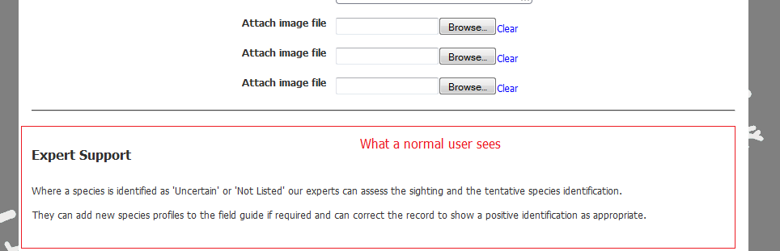

than what is presented to an administrator:

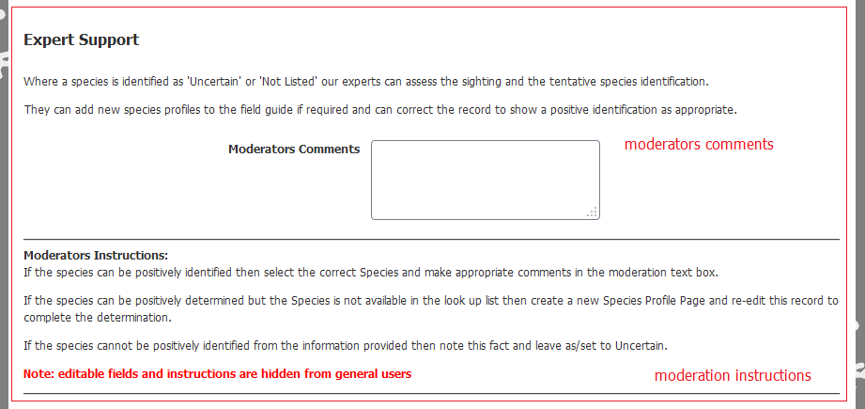

As you can see the administrator has their own comments field and instructions.

## Moderation Steps

1. Moderator selects an Unidentified/Uncertain or Not-Listed record from the list of records – View all records/My Sightings menu items.
2. Moderator reviews User content.
3. If the User has selected Not Listed the Moderator needs to confirm that the species in question is not listed in the Field guide.
   1. The User will usually have offered a common name for the species in question.
   2. The species may be listed in the Field Guide but under a different common name than the user is offering as the BDRS currently only supports a single common name for each species.
   3. If this is the case, and the identification is confirmed, then the Moderator changes the species selection to the name of the positively identified species, makes appropriate comments and resubmits the record and ***informs the user***.
   4. If the species is not present in the Field Guide then the Moderator needs to create a species profile page which can then be subsequently used to complete this record.
4. Where a positive identification cannot be made the Moderator makes appropriate comments and leaves species selection as Uncertain/Unidentified and ***informs the user***.

***Informs the user***

Moderators have access to the Admin Manage People / Manage Users process.

From here they can access the users email address as well as send emails.

This is an interim capability until the built in moderation process is fully implemented. We plan to have tighter integration in the final process so emails can be sent from the record moderation process itself.

## Adding a Species Worked Example

1. User has logged a sighting of Freckled Ducks.

This species is not in the WOMPA Species Field Guide so it is assigned to “Not Listed” so that the moderator knows to add the required species page.

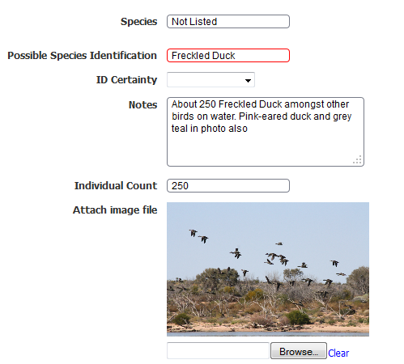

1. Moderator can see the record in reporting views – My Sightings and Advanced Review all public records:

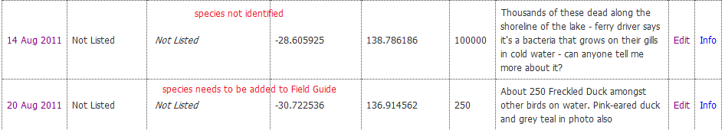

1. Moderator searches Atlas of Living Australia for Freckled Duck and finds <http://bie.ala.org.au/species/Stictonetta+naevosa>
2. Moderator adds species *Stictonetta naevosa* to WOMPA BDRS Field Guide – following the Import Taxonomy instructions in Managing Taxonomy 2012.docx manual.

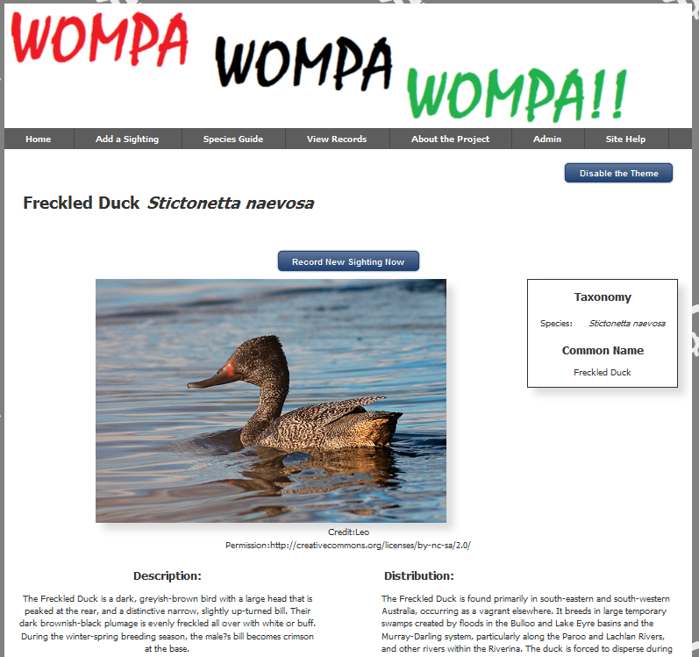

1. Moderator edits the record and assigns it to the correct species.

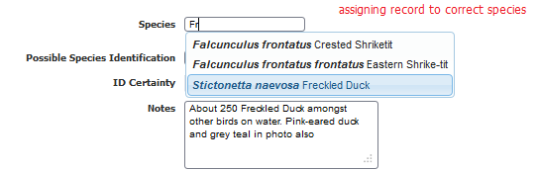

1. Moderator confirms ID Certainty – in this case Accepted (from a choice of Don’t Know : Possible : Likely : Accepted) because a) user is known to be able to identify this species and b) supporting image/s are of sufficient quality to make determination.

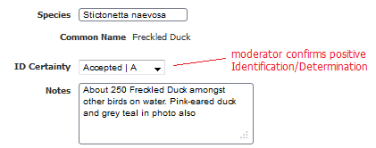

1. Moderator comments on process and Saves Changes
2. Record in reporting views:

